UNIT – IV
Other List Structures

Operation | Description
Create | Initializes a circular list with a single node pointing to itself.
Traverse | Displays all elements circularly.
Insert at Beginning | Adds new node before head, updates last node’s link.
Insert at End | Adds new node after last node, connects to head again.
Delete from Beginning | Removes first node and adjusts the last node’s link.
Delete from End | Removes last node, points previous node to head.
Search | Finds node with given value.
Count | Counts total nodes by looping circularly.

Primitive Operations on Circular Lists:

#include <stdio.h>
#include <stdlib.h>

// Structure definition for a node
struct Node {
int data;
struct Node* next;
};

struct Node* head = NULL; // global head pointer

// Function to create a circular linked list with one node
void create(int value) {
if (head != NULL) {
printf("List already exists!\n");
return;
}
struct Node* newNode = (struct Node*)malloc(sizeof(struct Node));
newNode->data = value;
newNode->next = newNode; // self-link for circular property
head = newNode;
printf("Circular list created with value %d\n", value);
}

// Function to traverse and display the list
void traverse() {
if (head == NULL) {
printf("List is empty.\n");
return;
}

struct Node* temp = head;
printf("Circular List Elements: ");
do {
printf("%d ", temp->data);
temp = temp->next;
} while (temp != head);
printf("\n");
}

// Insert at beginning
void insertAtBeginning(int value) {
struct Node* newNode = (struct Node*)malloc(sizeof(struct Node));
newNode->data = value;

if (head == NULL) {
newNode->next = newNode;
head = newNode;
return;
}

struct Node* temp = head;
while (temp->next != head)
temp = temp->next;

temp->next = newNode;
newNode->next = head;
head = newNode;

printf("%d inserted at beginning.\n", value);
}

// Insert at end
void insertAtEnd(int value) {
struct Node* newNode = (struct Node*)malloc(sizeof(struct Node));
newNode->data = value;

if (head == NULL) {
newNode->next = newNode;
head = newNode;
return;
}

struct Node* temp = head;
while (temp->next != head)
temp = temp->next;

temp->next = newNode;
newNode->next = head;
printf("%d inserted at end.\n", value);
}

// Delete from beginning
void deleteFromBeginning() {
if (head == NULL) {
printf("List is empty, nothing to delete.\n");
return;
}

struct Node* temp = head;
struct Node* last = head;

while (last->next != head)
last = last->next;

if (head->next == head) { // only one node
printf("%d deleted (last node).\n", head->data);
free(head);
head = NULL;
} else {
printf("%d deleted from beginning.\n", head->data);
head = head->next;
last->next = head;
free(temp);
}
}

// Delete from end
void deleteFromEnd() {
if (head == NULL) {
printf("List is empty, nothing to delete.\n");
return;
}

struct Node* temp = head;
struct Node* prev = NULL;

while (temp->next != head) {
prev = temp;
temp = temp->next;
}

if (temp == head) { // only one node
printf("%d deleted (last node).\n", head->data);
free(head);
head = NULL;
} else {
printf("%d deleted from end.\n", temp->data);
prev->next = head;
free(temp);
}
}

// Search for an element
void search(int key) {
if (head == NULL) {
printf("List is empty.\n");
return;
}

struct Node* temp = head;
int found = 0;
do {
if (temp->data == key)
{
found = 1;
break;
}
temp = temp->next;
} while (temp != head);

if (found)
printf("Element %d found in the list.\n", key);
else
printf("Element %d not found.\n", key);
}

// Count number of nodes
void countNodes()
{
if (head == NULL)
{
printf("List is empty.\n");
return;
}

int count = 0;
struct Node* temp = head;
do
{
count++;
temp = temp->next;
} while (temp != head);

printf("Total number of nodes = %d\n", count);
}

// Main function (Menu-driven)
int main() {
int choice, value;

while (1) {
printf("\n====== Circular Linked List Operations ======\n");
printf("1. Create Circular List\n");
printf("2. Traverse List\n");
printf("3. Insert at Beginning\n");
printf("4. Insert at End\n");
printf("5. Delete from Beginning\n");
printf("6. Delete from End\n");
printf("7. Search Element\n");
printf("8. Count Nodes\n");
printf("9. Exit\n");
printf("Enter your choice: ");
scanf("%d", &choice);

switch (choice) {
case 1:
printf("Enter value: ");
scanf("%d", &value);
create(value);
break;
case 2:
traverse();
break;
case 3:
printf("Enter value: ");
scanf("%d", &value);
insertAtBeginning(value);
break;
case 4:
printf("Enter value: ");
scanf("%d", &value);
insertAtEnd(value);
break;
case 5:
deleteFromBeginning();
break;
case 6:
deleteFromEnd();
break;
case 7:
printf("Enter value to search: ");
scanf("%d", &value);
search(value);
break;
case 8:
countNodes();
break;
case 9:
printf("Exiting program.\n");
exit(0);
default:
printf("Invalid choice! Try again.\n");
}
}
return 0;
}
Stack and queue as a circular linked list:
Circular Linked List Basics
A circular linked list is a linked list where the last node points back to the first node, forming a circle.
struct Node {
int data;
struct Node* next;
};

Properties:
- In a circular linked list, tail->next = head.
- It can be singly circular (one pointer per node) or doubly circular (two pointers per node).

Stack using Circular Linked List
A stack is LIFO (Last In First Out).
- Push → add at head
- Pop → remove from head
Implementation:
#include <stdio.h>
#include <stdlib.h>

struct Node {
int data;
struct Node* next;
};

struct Node* top = NULL; // top points to head of stack

void push(int value) {
struct Node* newNode = (struct Node*)malloc(sizeof(struct Node));
newNode->data = value;
if (top == NULL) {
newNode->next = newNode; // points to itself
top = newNode;
} else {
struct Node* temp = top;
while (temp->next != top)
temp = temp->next;
newNode->next = top;
temp->next = newNode;
top = newNode;
}
}

void pop() {
if (top == NULL) {
printf("Stack is empty\n");
return;
}
struct Node* temp = top;
if (top->next == top) { // only one node
top = NULL;
} else {
struct Node* last = top;
while (last->next != top)
last = last->next;
top = top->next;
last->next = top;
}
printf("Popped: %d\n", temp->data);
free(temp);
}

void display() {
if (top == NULL) {
printf("Stack is empty\n");
return;
}
struct Node* temp = top;
do {
printf("%d ", temp->data);
temp = temp->next;
} while (temp != top);
printf("\n");
}

int main() {
push(10);
push(20);
push(30);
display(); // 30 20 10
pop();
display(); // 20 10
return 0;
}

Queue using Circular Linked List
A queue is FIFO (First In First Out).
- Enqueue → add at tail
- Dequeue → remove from head
Implementation:

#include <stdio.h>
#include <stdlib.h>

struct Node
{
int data;
struct Node* next;
};

struct Node* rear = NULL; // rear points to last node

void enqueue(int value)
{
struct Node* newNode = (struct Node*)malloc(sizeof(struct Node));
newNode->data = value;
if (rear == NULL)
{
newNode->next = newNode;
rear = newNode;
}
else
{
newNode->next = rear->next; // new node points to front
rear->next = newNode;
rear = newNode; // new node becomes rear
}
}

void dequeue()
{
if (rear == NULL)
{
printf("Queue is empty\n");
return;
}
struct Node* front = rear->next;
if (rear == front)
{
// only one node
rear = NULL;
}
else
{
rear->next = front->next;
}
printf("Dequeued: %d\n", front->data);
free(front);
}

void display() {
if (rear == NULL) {
printf("Queue is empty\n");
return;
}
struct Node* temp = rear->next;
do {
printf("%d ", temp->data);
temp = temp->next;
} while (temp != rear->next);
printf("\n");
}

int main() {
enqueue(10);
enqueue(20);
enqueue(30);
display(); // 10 20 30
dequeue();
display(); // 20 30
return 0;
}

Doubly Circular Linked list in C
A node in a circular doubly linked list contains a data block, and two blocks (prev and next) to store the addresses of the previous node and the next node. The first (head) node contains the address of the last node in the prev block, and the last node's next block contains the address of the first (head) node.
Syntax:
struct node{
<data__type> data;
struct node* next;
struct node* prev;
};

Programs for Different Operations on the Circular Linked List in C
The following programs show the implementation of commonly used operations on a circular linked list in C language.

Insertion of a Node at the Beginning:
We can insert a node at the beginning of the circular linked list using the below procedure:
- Create a new node and assign it to a temporary variable.
- If our list is empty (head is NULL), then assign the new node's address in the head pointer and the new node's next pointer.
- If the list is not empty, assign the head node's address in a new current variable to traverse the list. Assign the new node's address in the last node (current).
- Update the new node's next block to point to the current first node by assigning the head node's address, then update the head pointer to point to the new node.

Diagrammatic Representation:
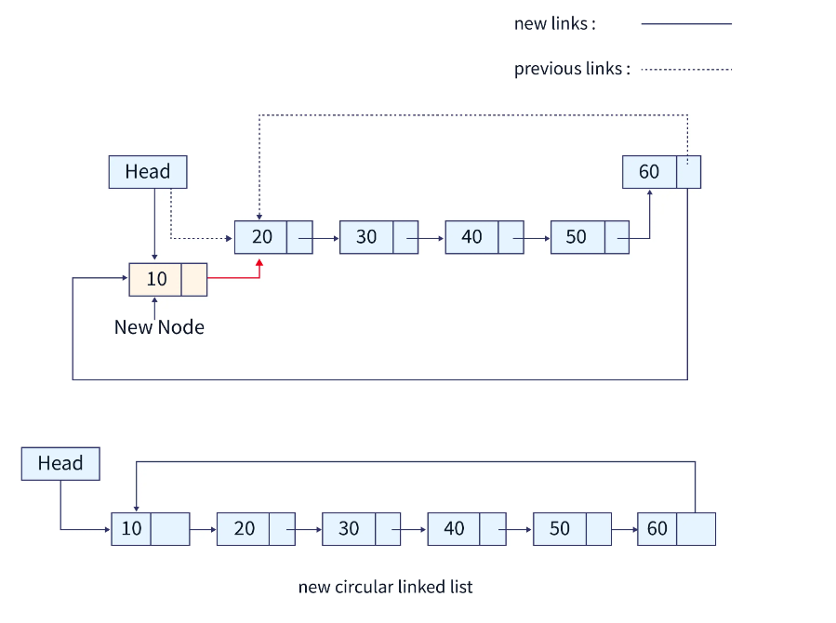
Below is the C program to add a node at the beginning of the circular linked list:
#include<stdio.h>
#include<stdlib.h>

// creating a structure for the circular singly linked list
struct node
{
int data;
struct node *next;
};

// code for creating a new node
struct node* createNode(){
struct node *n;
n = (struct node*)malloc(sizeof(struct node));
return n;
}

void insertNodeAtBeginning(struct node** head, int data){
struct node* temp, *current;

// creating the new node
temp = createNode();
temp->data = data;
temp->next = NULL;

// if the list is empty
if(*head == NULL){
*head = temp;
temp->next = *head;
return;
}

// if the list already has more than 1 node
current = *head;

while(current->next != *head){
current = current->next;
}

current->next = temp;
temp->next = *head;
*head = temp;
return;
}

// code for displaying the list in the output
void viewList(struct node** head){
struct node *temp;

// if the list is empty
if(*head == NULL){
printf("List is empty.\n");
return;
}else{ // if the list has one or more nodes.
temp = *head;
printf("List: ");
do{
printf("%d ", temp->data);
temp = temp->next;
}
while(temp != *head);
}
}

int main(){

struct node* head = NULL;

// inserting different values in the list,
// 10 will be the first and 60 will be the last node
insertNodeAtBeginning(&head, 60);
insertNodeAtBeginning(&head, 50);
insertNodeAtBeginning(&head, 40);
insertNodeAtBeginning(&head, 30);
insertNodeAtBeginning(&head, 20);
insertNodeAtBeginning(&head, 10);

// viewing the list
viewList(&head);

return 0;
}

Output:
List: 10 20 30 40 50 60

Time and Space Complexities:
O(1) is the time and space complexity of this operation since the insertion operation at the beginning needs a constant space and a constant amount of time.
Explanation:
In the above C program, we have created a structure for the circular singly linked list. Using this structure, we have implemented a createNode() function to create new nodes using the dynamic memory allocation function malloc(). We have also created an insertNodeAtBeginning() function to insert the nodes in the circular linked list. It takes two arguments, first the address of the head node and second the data for the new node. Also, the viewList() function can be used to view the entire list.

Insertion of a Node at the End:
We can insert a node at the end of the circular linked list using the below procedure:
- Create a new node and assign it to a temporary variable.
- If our list is empty (head is NULL), then assign the new node's address in the head pointer and the new node's next pointer.
- If the list is not empty, assign the head node address in a new current variable to traverse the list. Assign the new node's address in the last node (current).
- Update the new node's next block to point to the current first node by assigning the head node's address.
Diagrammatic Representation:
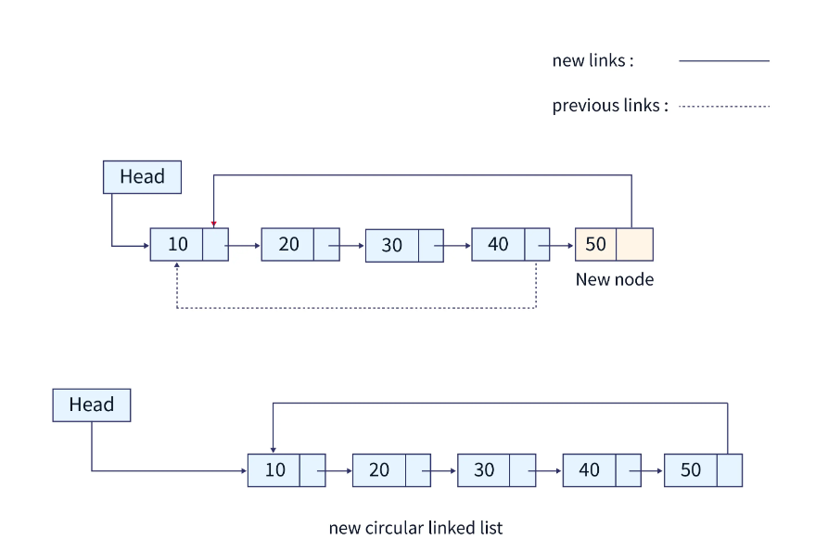

Below is the C program to add a node at the end of the circular linked list:
#include<stdio.h>
#include<stdlib.h>

// creating a structure for the circular singly linked list
struct node
{
int data;
struct node *next;
};

// code for creating a new node
struct node* createNode(){
struct node *n;
n = (struct node*)malloc(sizeof(struct node));
return n;
}

void insertNodeAtEnd(struct node** head, int data){
struct node* temp, *current;

// creating the new node
temp = createNode();
temp->data = data;
temp->next = NULL;

// if the list is empty, we assign the new node to the head pointer
if(*head == NULL){
*head = temp;
temp->next = *head;
return;
}

// if the list has one or more than one node already
current = *head;

while(current->next != *head){
current = current->next;
}

current->next = temp;
temp->next = *head;
}

// code for displaying the list in the output
void viewList(struct node** head){
struct node *temp;

// if the list is empty
if(*head == NULL){
printf("List is empty.\n");
return;
}else{ // if the list has one or more nodes.
temp = *head;
printf("List: ");
do{
printf("%d ", temp->data);
temp = temp->next;
}
while(temp != *head);
}
}

int main(){

struct node* head = NULL;

// inserting different values in the list,
// 3 will be the first node and 18 will be the last node
insertNodeAtEnd(&head, 10);
insertNodeAtEnd(&head, 20);
insertNodeAtEnd(&head, 30);
insertNodeAtEnd(&head, 40);
insertNodeAtEnd(&head, 50);

// viewing the list
viewList(&head);

return 0;
}

Output:
List: 10 20 30 40 50

Time and Space Complexities:
O(1) is the time and space complexity of this operation since the insertion operation at the end also needs a constant space and a constant amount of time.
Explanation:
Similar to the first C program, we have created a structure for the circular singly linked list. We have created an insertNodeAtEnd() function to insert new nodes at the end of the list. It takes two arguments, first the address of the head pointer and second the data for the new node. We can view the entire list using the viewList() function.

Insertion of a Node After a Specific Element
We can insert a node after a specific element in the circular linked list using the below procedure:
- Create a new node and assign it to a new node variable.
- Assign the head node address in a new temp variable, and traverse the list till the next node contains the specified value.
- Assign the next node's address in the new node variable.
- Update the current node's next block address to point to the new node.

Diagrammatic Representation:
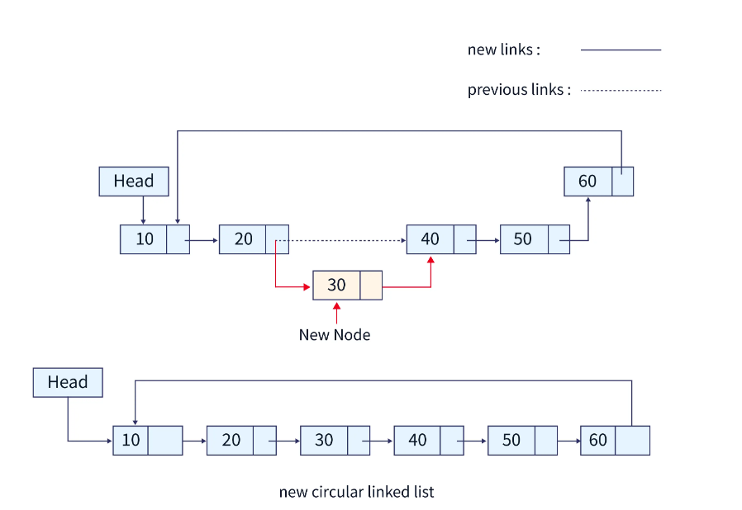

Below is the program to add a node after a specific value in the circular linked list in C:
#include<stdio.h>
#include<stdlib.h>

// creating a structure for the circular singly linked list
struct node
{
int data;
struct node *next;
};

// code for creating a new node
struct node* createNode(){
struct node *n;
n = (struct node*)malloc(sizeof(struct node));
return n;
}

void insertNodeAtEnd(struct node** head, int data){
struct node* temp, *current;

// creating the new node
temp = createNode();
temp->data = data;
temp->next = NULL;

// if the list is empty
if(*head == NULL){
*head = temp;
temp->next = *head;
return;
}

// if the list already has more than 1 node
current = *head;

while(current->next != *head){
current = current->next;
}

current->next = temp;
temp->next = *head;
return;
}

// code to insert a new node after a specific value node in the list
void insertAfterSpecificNode(struct node** head, int data, int value){
struct node* temp, *newNode;

// creating a new node
newNode = createNode();
newNode->data = data;
newNode->next = NULL;

// traversing the list till the value is found
temp = *head;

while(temp->data != value){
temp = temp->next;
}

// adding the newNode b/w the "value" data node and next node.
newNode->next = temp->next;
temp->next = newNode;
return;
}

// code for displaying the list in the output
void viewList(struct node** head){
struct node *temp;

// if the list is empty
if(*head == NULL){
printf("List is empty.\n");
return;
}else{ // if the list has one or more nodes.
temp = *head;
printf("List: ");
do{
printf("%d ", temp->data);
temp = temp->next;
}
while(temp != *head);
}
printf("\n");
}

int main(){

struct node* head = NULL;

// inserting different values in the list,
// 3 will be the first and 18 will be the last node
insertNodeAtEnd(&head, 3);
insertNodeAtEnd(&head, 6);
insertNodeAtEnd(&head, 9);
insertNodeAtEnd(&head, 12);
insertNodeAtEnd(&head, 18);
insertNodeAtEnd(&head, 21);

// viewing the list
viewList(&head);

// inserting the node after node containing 12 data values.
// parameters (head, newNodedata, valueAfterTheNodeIsInserted)
insertAfterSpecificNode(&head, 15, 12);

viewList(&head);

return 0;
}
Time and Space Complexities:
O(n) is the time complexity for this operation since the insertion operation at a specific position requires the traversal of the list. O(1) is the space complexity as it requires constant space.
Explanation:
Similar to the above C programs, we have created a circular singly linked list. To insert a node after a specific node, we have created an insertAfterSpecificNode() function. It takes three arguments, first the address of the head pointer, second the data for the new node, and third the data of the node after we have to add the new node. We can view the entire list to check the list after the operation using the viewList() function.

Deleting the First Node
We can delete the first node of a circular linked list in C using the below procedure:
- If the list has only one node, then delete the head node by using the free() function directly.
- Create two temporary variables and store the head address in them.
- Traverse the list to the last node and assign the head's next node address to the last node.
- Update the head pointer to point to the next node.
- free the temporary variable which still points to the first node.
Diagrammatic Representation:
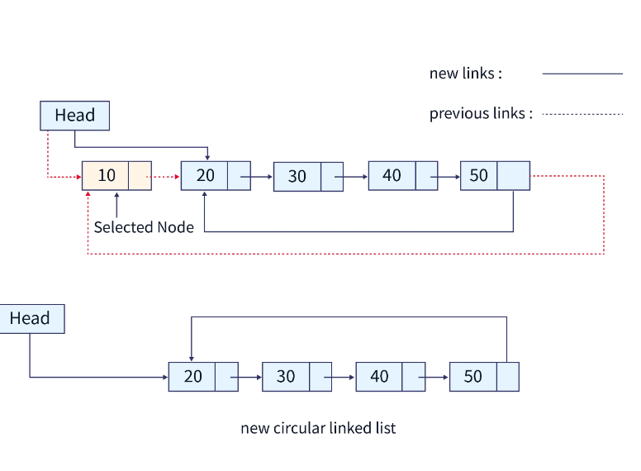
Below is the C program to delete the first node from the circular linked list:
#include<stdio.h>
#include<stdlib.h>

// creating a structure for the circular singly linked list
struct node
{
int data;
struct node *next;
};

// code for creating a new node
struct node* createNode(){
struct node *n;
n = (struct node*)malloc(sizeof(struct node));
return n;
}

void insertNodeAtEnd(struct node** head, int data){
struct node* temp, *current;

// creating the new node
temp = createNode();
temp->data = data;
temp->next = NULL;

// if the list is empty
if(*head == NULL){
*head = temp;
temp->next = *head;
return;
}

// if the list already has more than 1 node
current = *head;

while(current->next != *head){
current = current->next;
}

current->next = temp;
temp->next = *head;
return;
}

// code to delete the first node from the list
void deleteFirstNode(struct node** head){
struct node* temp = *head;
struct node* current = *head;

if(*head == NULL){
printf("List empty.");
return;
}else if((*head)->next == *head){ // if there is only one node in the list
*head = NULL;
free(temp);
return;
}

// traversing the list till the last node
while(current->next != *head){
current = current->next;
}

// assigning head node pointer to the last node to make the list circular
current->next = (*head)->next;

// assigning the address of the next node in the head node.
*head = (*head)->next;

// removing the first node from the memory
free(temp);
return;
}

// code for displaying the list in the output
void viewList(struct node** head){
struct node *temp;

// if the list is empty
if(*head == NULL){
printf("List is empty.\n");
return;
}else{ // if the list has one or more nodes.
temp = *head;
printf("List: ");
do{
printf("%d ", temp->data);
temp = temp->next;
}
while(temp != *head);
}
printf("\n");
}

int main(){

struct node* head = NULL;

// inserting different values in the list,
// 3 will be the first and 18 will be the last node
insertNodeAtEnd(&head, 3);
insertNodeAtEnd(&head, 6);
insertNodeAtEnd(&head, 9);
insertNodeAtEnd(&head, 12);
insertNodeAtEnd(&head, 18);
insertNodeAtEnd(&head, 21);

// viewing the list
viewList(&head);

// deleting the first node i.e. 3
deleteFirstNode(&head);

viewList(&head);

return 0;
}

Output:
List: 3 6 9 12 18 21
List: 6 9 12 18 21

Time and Space Complexities:
O(1) is the time and space complexity of this operation since the deletion of the first node needs a constant space and a constant amount of time.
Explanation:
To delete the first node, we have created a deleteFirstNode() function which takes only one parameter, i.e., the address of the head pointer. We have to make sure that the last node's next block address is also updated to the second node after deleting the first node.

Deleting the Last Node
We can delete the last node of a circular linked list using the below procedure:
- If the list has only one node, then delete the head node by using the free() function directly.
- Create two temporary variables and store the head address in one of them.
- Traverse the list till the second last node and assign the last node address in a temporary node variable.
- Update the second last node pointer to point to the head node.
- free the temporary variable which still points to the last node.
Diagrammatic Representation:
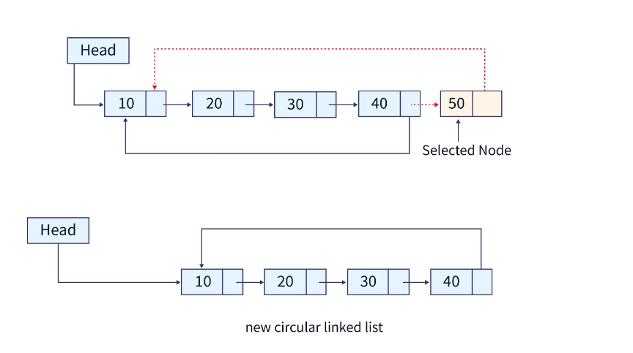
Below is the C program to delete the last node from the circular linked list:
#include<stdio.h>
#include<stdlib.h>

// creating a structure for the circular singly linked list
struct node
{
int data;
struct node *next;
};

// code for creating a new node
struct node* createNode(){
struct node *n;
n = (struct node*)malloc(sizeof(struct node));
return n;
}

void insertNodeAtBeginning(struct node** head, int data){
struct node* temp, *current;

// creating the new node
temp = createNode();
temp->data = data;
temp->next = NULL;

// if the list is empty
if(*head == NULL){
*head = temp;
temp->next = *head;
return;
}

// if the list already has more than 1 node
current = *head;

while(current->next != *head){
current = current->next;
}

current->next = temp;
temp->next = *head;
*head = temp;
}

// code to delete the last node from the list
void deleteLastNode(struct node** head){
struct node* temp;
struct node* current = *head;

if(*head == NULL){
printf("List empty.");
return;
}

// traversing the list till the last node
while(current->next->next != *head){
current = current->next;
}

temp = current->next;
// assigning head node pointer to the second last node to make the list circular
current->next = *head;

// removing the first node from the memory
free(temp);
return;
}

// code for displaying the list in the output
void viewList(struct node** head){
struct node *temp;

// if the list is empty
if(*head == NULL){
printf("List is empty.\n");
return;
}else{ // if the list has one or more nodes.
temp = *head;
printf("List: ");
do{
printf("%d ", temp->data);
temp = temp->next;
}
while(temp != *head);
}
printf("\n");
}

int main(){

struct node* head = NULL;

// inserting different values in the list,
// 12 will be the first and 2 will be the last node
insertNodeAtBeginning(&head, 2);
insertNodeAtBeginning(&head, 4);
insertNodeAtBeginning(&head, 6);
insertNodeAtBeginning(&head, 8);
insertNodeAtBeginning(&head, 10);
insertNodeAtBeginning(&head, 12);

// viewing the list
viewList(&head);

// deleting the last node i.e. 2
deleteLastNode(&head);

viewList(&head);

return 0;
}

Output:
List: 12 10 8 6 4 2
List: 12 10 8 6 4

Time and Space Complexities: O(n) is the time complexity for this operation since the deletion operation at the last position requires the traversal of the list. O(1) is the space complexity as it requires constant space.
Explanation: To delete the last node, we have created a deleteLastNode() function which takes only one parameter, i.e., the address of the head pointer. We also have to make sure that the second last node's next block's address is also updated to the first (head) node's address after deleting the last node.

Deleting a Node at a Given Point
We can delete the last node of a circular linked list using the below procedure:
- Check if the position is first, then apply the algorithm for deleting the first node from a circular linked list (mentioned above).
- Create two temporary variables and store the head address in one of them.
- Traverse the list till the previous node to the node to be deleted and assign the position's next node address in a temporary node variable.
- Update the previous node pointer to point to the current's next node.
- free the temporary variable which still points to the position node.
Diagrammatic Representation:
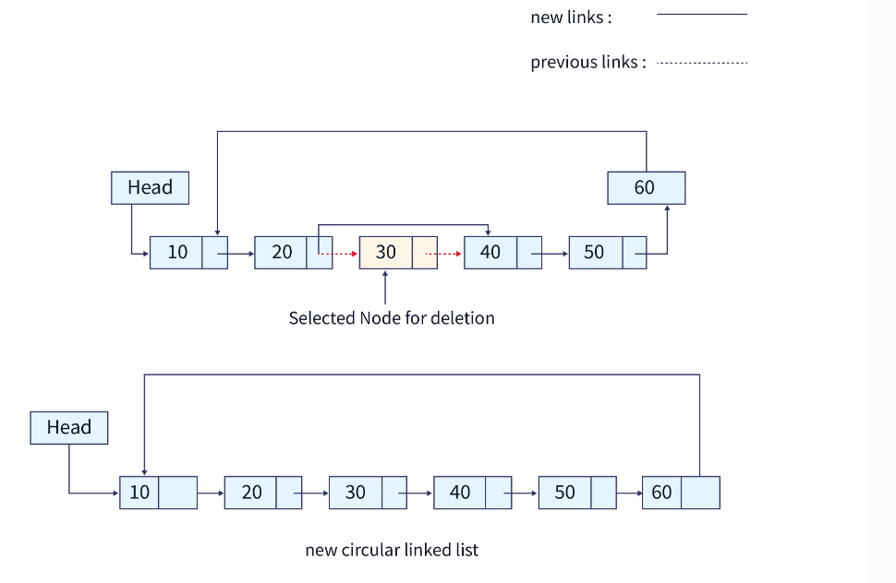

Below is the C program to delete a node at a given point (position) from the circular linked list:
#include<stdio.h>
#include<stdlib.h>

// creating a structure for the circular singly linked list
struct node
{
int data;
struct node *next;
};

// code for creating a new node
struct node* createNode(){
struct node *n;
n = (struct node*)malloc(sizeof(struct node));
return n;
}

void insertNodeAtEnd(struct node** head, int data){
struct node* temp, *current;

// creating the new node
temp = createNode();
temp->data = data;
temp->next = NULL;

// if the list is empty
if(*head == NULL){
*head = temp;
temp->next = *head;
return;
}

// if the list already has more than 1 node
current = *head;

while(current->next != *head){
current = current->next;
}

current->next = temp;
temp->next = *head;
return;
}

// code to delete a node at a specific position from the list
void deleteAtPosition(struct node** head, int pos)
{
if(pos > 6 || pos < 1){
printf("Invalid position to delete a node.\n");
return;
}
int i = 1;
struct node *temp, *position;
temp = *head;

if (*head == NULL)
{ // if list is empty
printf("\nList is empty.\n");
}
else
{
printf("Deleted the node at position: %d\n", pos);
// if the first node is to be deleted
if(pos == 1){
position = *head;

while(temp->next != *head){
temp = temp->next;
}

temp->next = (*head)->next;
*head = (*head)->next;
free(position);
return;
}
// traversing the list till the previous node position is reached
while (i <= pos - 2) {
temp = temp->next;
i++;
}

// temp is now pointing to the previous node to the node to be deleted

// reassigning links
position = temp->next;
temp->next = position->next;

free(position);
return;
}
}

// code for displaying the list in the output
void viewList(struct node** head){
struct node *temp;

// if the list is empty
if(*head == NULL){
printf("List is empty.\n");
return;
}else{ // if the list has one or more nodes.
temp = *head;
printf("List: ");
do{
printf("%d ", temp->data);
temp = temp->next;
}
while(temp != *head);
}
printf("\n");
}

int main(){

struct node* head = NULL;

// inserting different values in the list,
// 1 will be the first and 6 will be the last node
insertNodeAtEnd(&head, 1);
insertNodeAtEnd(&head, 2);
insertNodeAtEnd(&head, 3);
insertNodeAtEnd(&head, 4);
insertNodeAtEnd(&head, 5);
insertNodeAtEnd(&head, 6);

// viewing the list
viewList(&head);

// deleting the third position node i.e. 3
deleteAtPosition(&head, 3);

viewList(&head);

return 0;
}

Output:
List: 1 2 3 4 5 6
Deleted the node at position: 3
List: 1 2 4 5 6

Time and Space Complexities:
O(n) is the time complexity for this operation since the deletion operation at a specified position requires the traversal of the list. O(1) is the space complexity as it requires constant space.
Explanation:
To delete a node at a specific position, we have created a deleteAtPosition() function which takes two parameters, i.e., the address of the head pointer and the position. We have covered all possible test cases in the above program, like deleting the first or last node. We can view the list after the operation to check its validity using the viewList() function.

Example for Understanding
We can use a circular linked list to implement a stack data structure. Let us look at the similarity of operations between stack and circular linked lists:
- PUSH: Push operation in the stack is similar to the insertion of a node at the beginning of the circular linked list.
- POP: Pop operation is similar to the deletion of the first node from the circular linked list.
- TOP: Top points to the first node, i.e., the head pointer in terms of the circular linked list.
- ViewStack: Stack can be viewed simply by traversing the circular linked list.
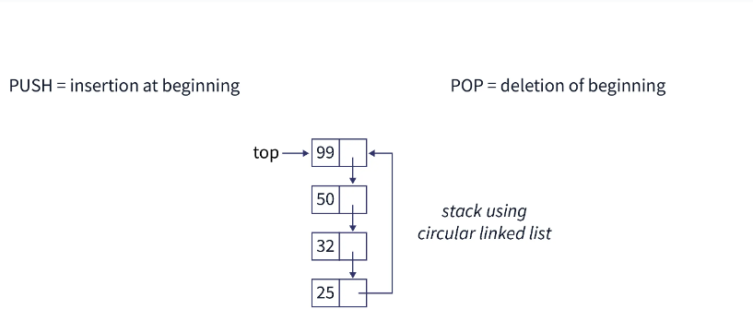

C Program to Implement Stack Data Structure Using Circular Linked List:
#include<stdio.h>
#include<stdlib.h>

// creating a structure for the circular singly linked list
struct node
{
int data;
struct node *next;
};

// code for creating a new node
struct node* createNode()
{
struct node *n;
n = (struct node*)malloc(sizeof(struct node));
return n;
}

// insertion at the beginning of the list is the push operation
struct node* push(int data, struct node* top)
{
struct node* temp = createNode();
temp->data = data;
temp->next = NULL;

// if the top of the stack is NULL, we push the item in the stack
if(top == NULL)
{
top = temp;
top->next = top;
return top;
}
else{
temp->next = top->next;
}

top->next = temp;

return top;
}

// deletion of the front node is the POP operation
struct node* pop(struct node* top)
{
struct node* first;

if(top == NULL) // empty list
{
printf("Cannot delete, Empty Stack -> Stack Underflow condition.\n");
return NULL;
}

if(top->next == top)
{
printf("Popped item is %d\n", top->data);
free(top);
return NULL;
}

first = top->next;

printf("Popped item is %d\n", first->data);

top->next = first->next;

free(first);

return top;
}

// to display the list in form of a stack
void viewStack(struct node* top)
{
struct node* current;

if(top == NULL)
{
printf("Empty Stack -> Stack Underflow condition.\n");
return;
}

if(top->next == top)
{
printf("%d\n", top->data);
return;
}

current = top;

while(current->next != top)
{
current = current->next;
printf("%d\n", current->data);
}

current = current->next;
printf("%d\n", current->data);
}

int main()
{
int choice, data;

struct node* top;

top = NULL;

printf("Implementation of Stack data structure using Circular Linked List.\n");

while(1)
{
printf("Select a choice:\n");
printf("1. Push\n2. Pop\n3. View Stack\n4. Exit\n");
printf("Choice: ");
scanf("%d", &choice);

switch(choice)
{
case 1:
printf("Enter the data to be inserted in the stack: ");
scanf("%d", &data);
top = push(data, top);
break;
case 2:
top = pop(top);
break;
case 3:
viewStack(top);
break;
default:
exit(0);
}
}

return 0;
}

Output:
Implementation of Stack data structure using Circular Linked List.
Select a choice:
1. Push
2. Pop
3. View Stack
4. Exit
Choice: 1
Enter the data to be inserted in the stack: 3
Select a choice:
1. Push
2. Pop
3. View Stack
4. Exit
Choice: 1
Enter the data to be inserted in the stack: 4
Select a choice:
1. Push
2. Pop
3. View Stack
4. Exit
Choice: 1
Enter the data to be inserted in the stack: 5
Select a choice:
1. Push
2. Pop
3. View Stack
4. Exit
Choice: 3
5
4
3
Select a choice:
1. Push
2. Pop
3. View Stack
4. Exit
Choice: 2
Popped item is 5
Select a choice:
1. Push
2. Pop
3. View Stack
4. Exit
Choice: 2
Popped item is 4
Select a choice:
1. Push
2. Pop
3. View Stack
4. Exit
Choice: 2
Popped item is 3
Select a choice:
1. Push
2. Pop
3. View Stack
4. Exit
Choice: 2
Cannot delete, Empty Stack -> Stack Underflow condition.
Select a choice:
1. Push
2. Pop
3. View Stack
4. Exit
Choice: 3
Empty Stack -> Stack Underflow condition.
Select a choice:
1. Push
2. Pop
3. View Stack
4. Exit
Choice: 4

Time and Space Complexity:
O(1) is the time and space complexity for all the operations, since the PUSH (insertion at the beginning), and POP (deletion at the beginning) operations need constant space and a constant amount of time.
Explanation:
Implementation of stack using a circular linked list is very simple. The PUSH operation of the stack is similar to the insertion of a node at beginning of the list, POP operation is similar to the deletion of a node from the beginning. A TOP is maintained in the stack, similar to the head pointer in the circular linked list. We can also view the stack using the viewStack() function defined in the program, which is also similar to the viewList() function as seen in the above C programs.
- A circular linked list is just a modification to normally linked lists, every node in a circular linked list is connected one after the other in a sequence, and the last node points to the initial node.
- The circular linked lists do not have any end as the last node always contains the address of the first (head) node which makes it circular.
- We must be cautious when navigating circular linked lists in order to avoid endlessly exploring the list.
- A computer's computational resources are managed via circular linked lists. Circular linked lists can also be used to implement stacks and queues.

Queue as a Circular List :

Circular Singly Linked List We have discussed basics and how to implement circular queue using array in set 1. Circular Queue | Set 1 (Introduction and Array Implementation) In this post another method of circular queue implementation is discussed, using Circular Singly Linked List.
Operations on Circular Queue:
- Front:Get the front item from queue.
- Rear: Get the last item from queue.
- enQueue(value) This function is used to insert an element into the circular queue. In a circular queue, the new element is always inserted at Rear position.
  - Create a new node dynamically and insert value into it.
  - Check if front==NULL, if it is true then front = rear = (newly created node)
  - If it is false then rear=(newly created node) and rear node always contains the address of the front node.
- deQueue() This function is used to delete an element from the circular queue. In a queue, the element is always deleted from front position.
  - Check whether queue is empty or not means front == NULL.
  - If it is empty then display Queue is empty. If queue is not empty then step 3
  - Check if (front==rear) if it is true then set front = rear = NULL else move the front forward in queue, update address of front in rear node and return the element.
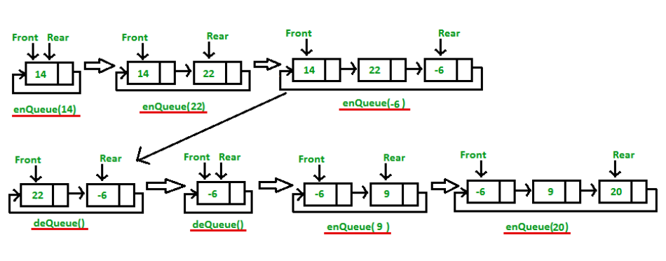

Below is the implementation of the above approach:

#include<stdio.h>
#include<stdlib.h>

struct node
{
int data;
struct node *next;
};

struct node *f = NULL;
struct node *r = NULL;

void enqueue (int d) //Insert elements in Queue
{
struct node *n;
n = (struct node *) malloc (sizeof (struct node));
n->data = d;
n->next = NULL;
if ((r == NULL) && (f == NULL))
{
f = r = n;
r->next = f;
}
else
{
r->next = n;
r = n;
n->next = f;
}
}

void dequeue () // Delete an element from Queue
{
struct node *t;
t = f;
if ((f == NULL) && (r == NULL))
printf ("\nQueue is Empty");
else if (f == r)
{
f = r = NULL;
free (t);
}
else
{
f = f->next;
r->next = f;
free (t);
}

}

void display ()
{ // Print the elements of Queue
struct node *t;
t = f;
if ((f == NULL) && (r == NULL))
printf ("\nQueue is Empty");
else
{
do
{
printf (" %d", t->data);
t = t->next;
}
while (t != f);
}
}

int main ()
{
enqueue (34);
enqueue (22);
enqueue (75);
enqueue (99);
enqueue (27);
printf ("Circular Queue: ");
display ();
printf ("\n");

dequeue ();
printf ("Circular Queue After dequeue: ");
display ();
return 0;
}

Doubly Linked List:
Doubly linked list is a complex type of linked list in which a node contains a pointer to the previous as well as the next node in the sequence. Therefore, in a doubly linked list, a node consists of three parts: node data, pointer to the next node in sequence (next pointer) , pointer to the previous node (previous pointer). A sample node in a doubly linked list is shown in the figure.
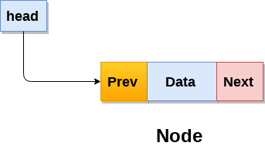
A doubly linked list containing three nodes having numbers from 1 to 3 in their data part, is shown in the following image.
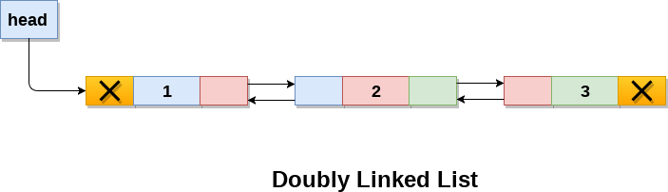
In C, structure of a node in doubly linked list can be given as :
- struct node
- {
- struct node *prev;
- int data;
- struct node *next;
- }
The prev part of the first node and the next part of the last node will always contain null indicating end in each direction.
In a singly linked list, we could traverse only in one direction, because each node contains address of the next node and it doesn't have any record of its previous nodes. However, doubly linked list overcome this limitation of singly linked list. Due to the fact that, each node of the list contains the address of its previous node, we can find all the details about the previous node as well by using the previous address stored inside the previous part of each node.

Memory Representation of a doubly linked list
Memory Representation of a doubly linked list is shown in the following image. Generally, doubly linked list consumes more space for every node and therefore, causes more expansive basic operations such as insertion and deletion. However, we can easily manipulate the elements of the list since the list maintains pointers in both the directions (forward and backward).
In the following image, the first element of the list that is i.e. 13 stored at address 1. The head pointer points to the starting address 1. Since this is the first element being added to the list therefore the prev of the list contains null. The next node of the list resides at address 4 therefore the first node contains 4 in its next pointer.
We can traverse the list in this way until we find any node containing null or -1 in its next part.
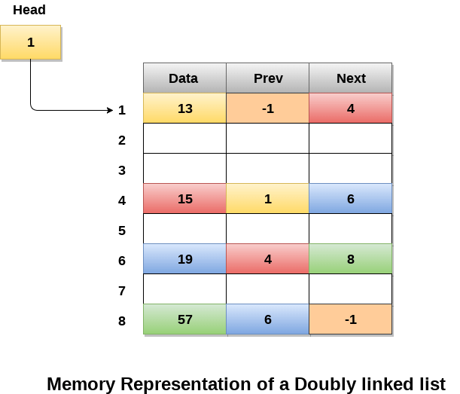

Operations on doubly linked list
Node Creation
- struct node
- {
- struct node *prev;
- int data;
- struct node *next;
- };
- struct node *head;

All the remaining operations regarding doubly linked list are described in the following table.
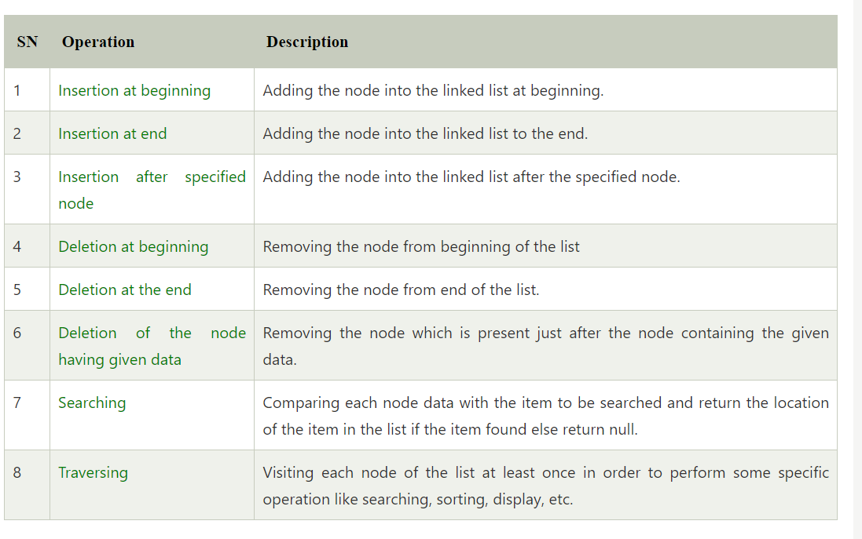

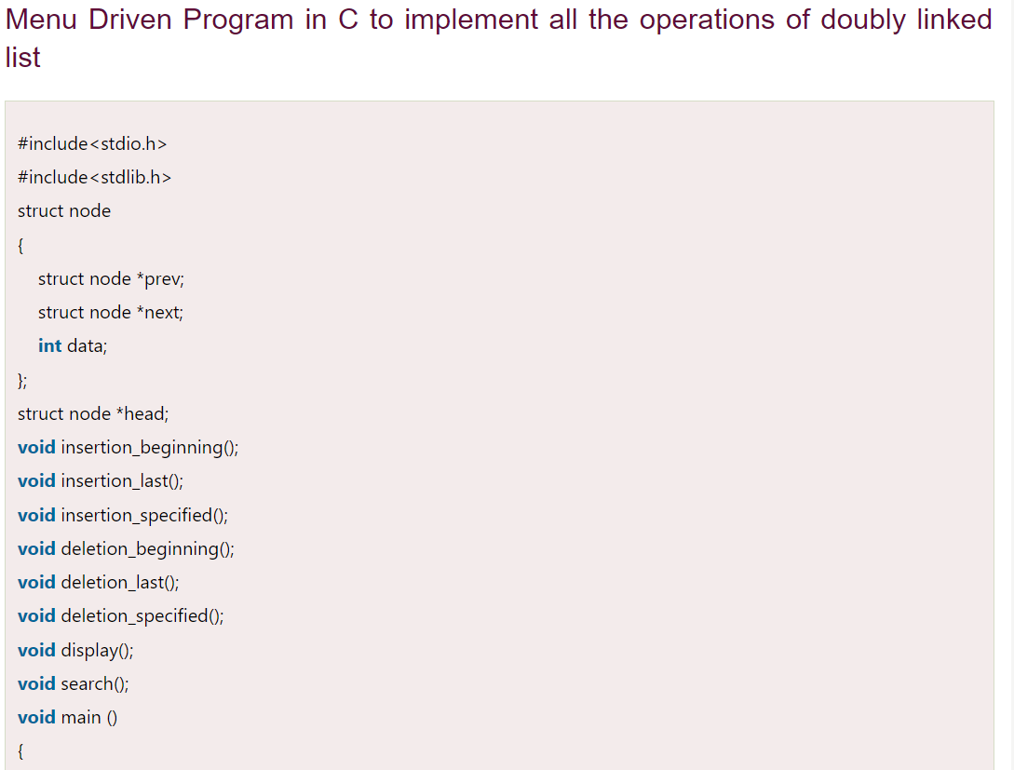

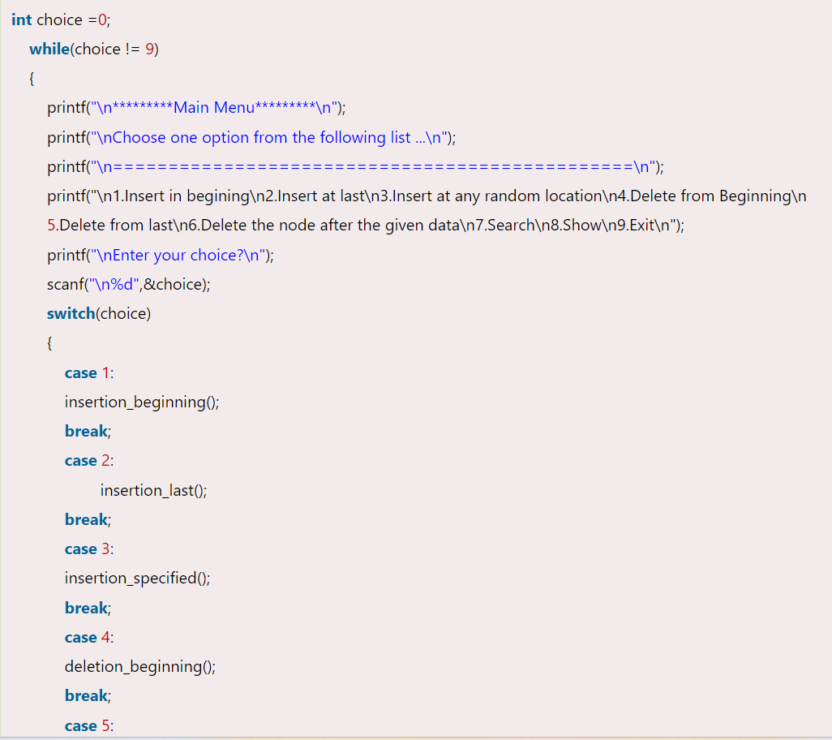
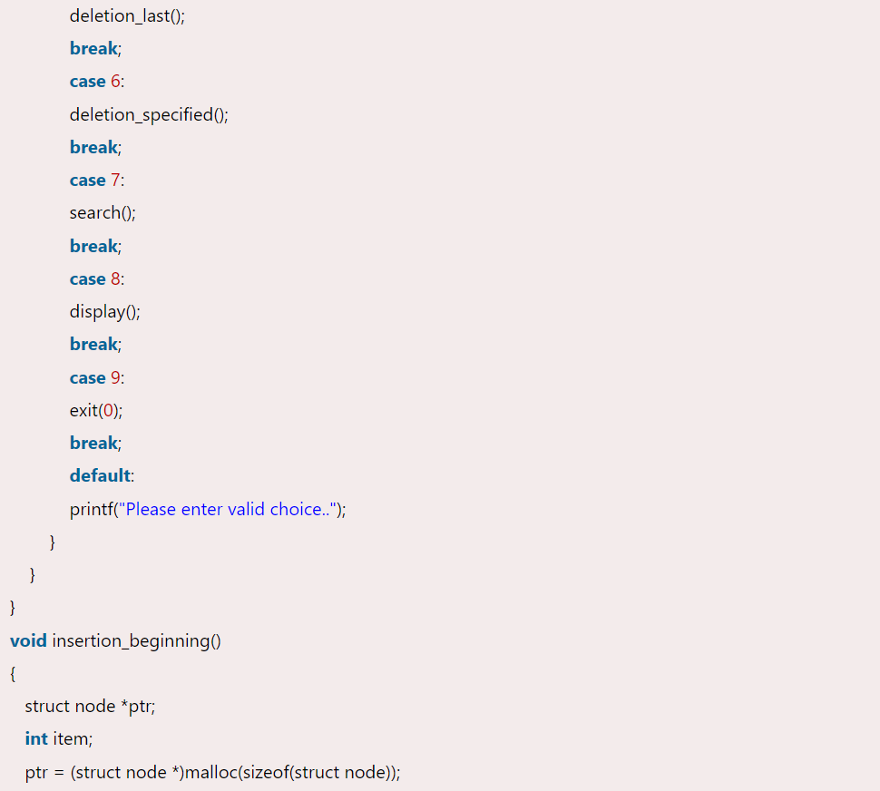

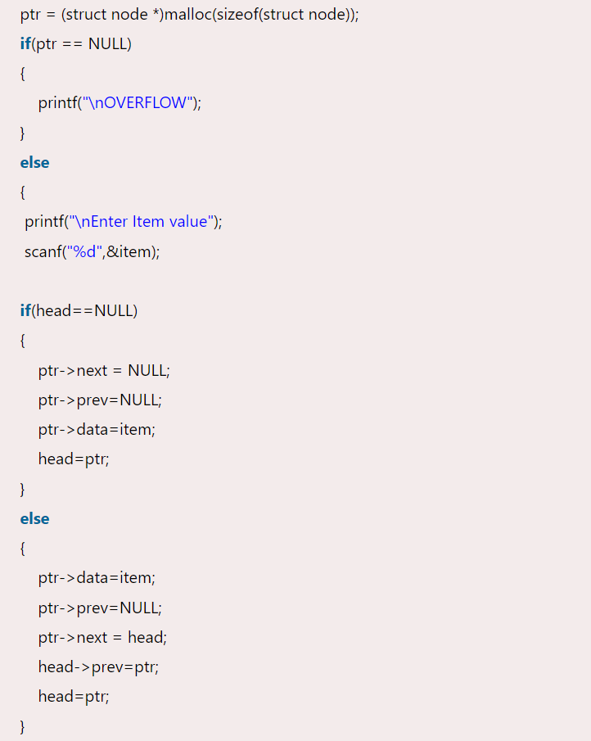

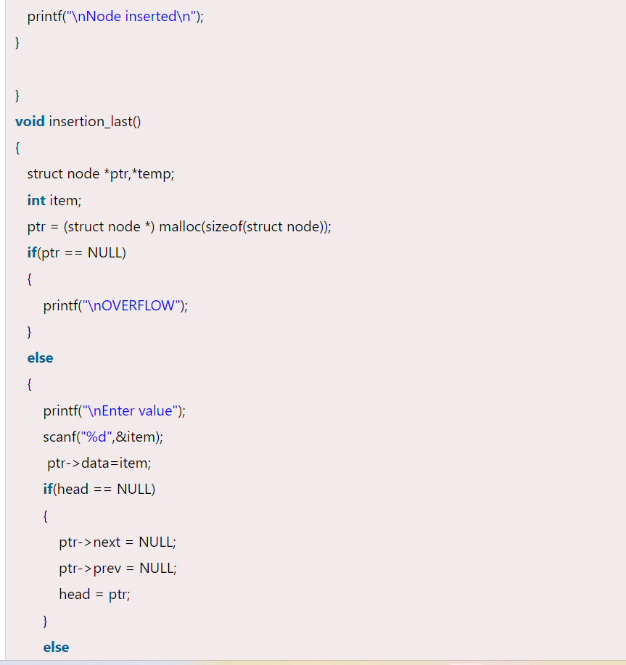
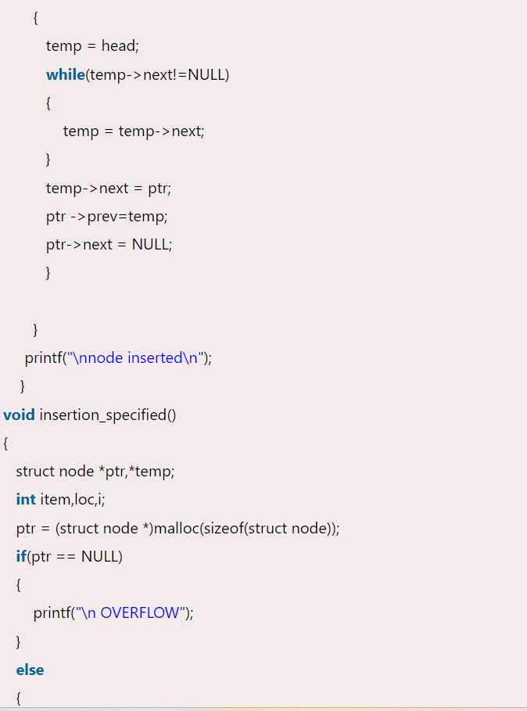
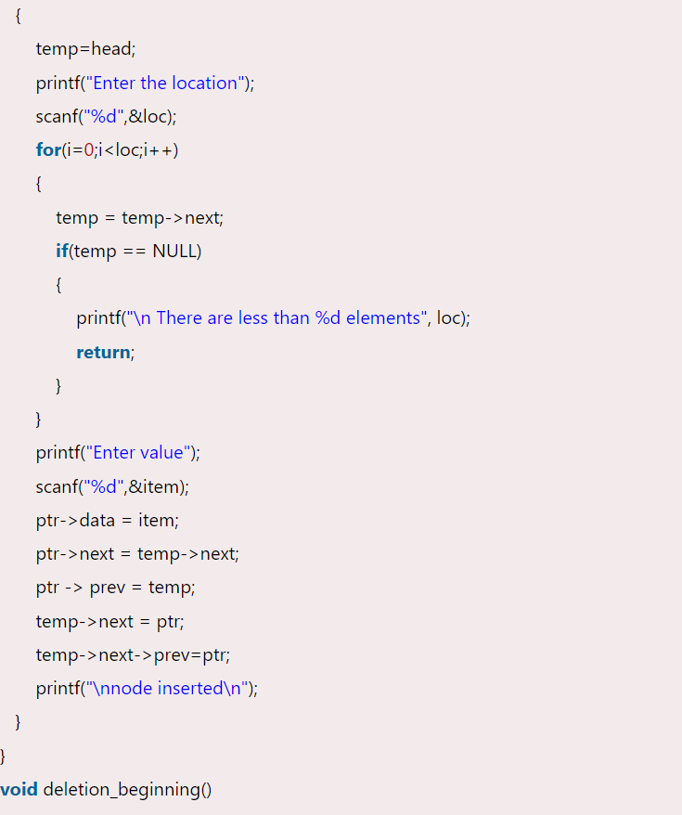
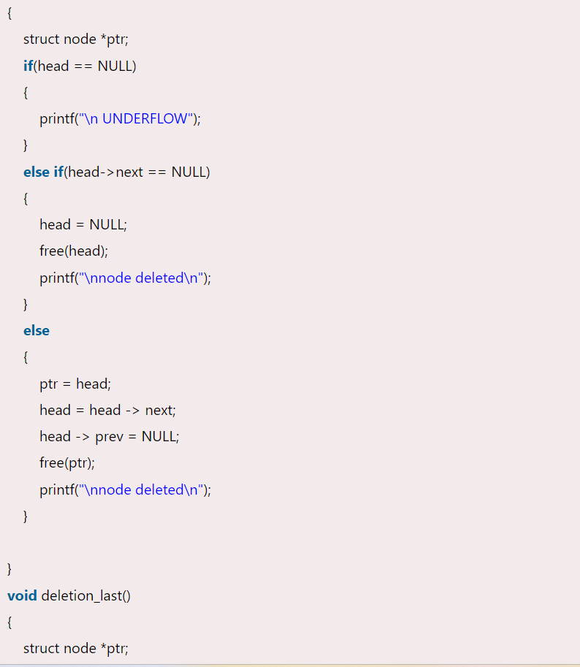
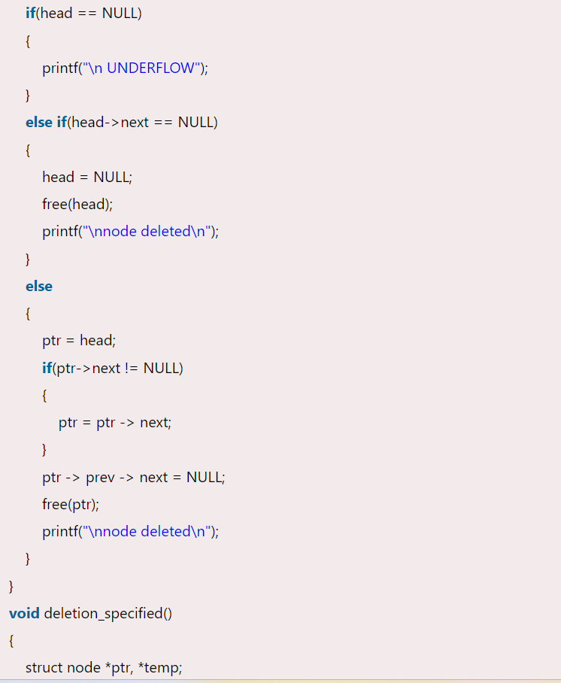
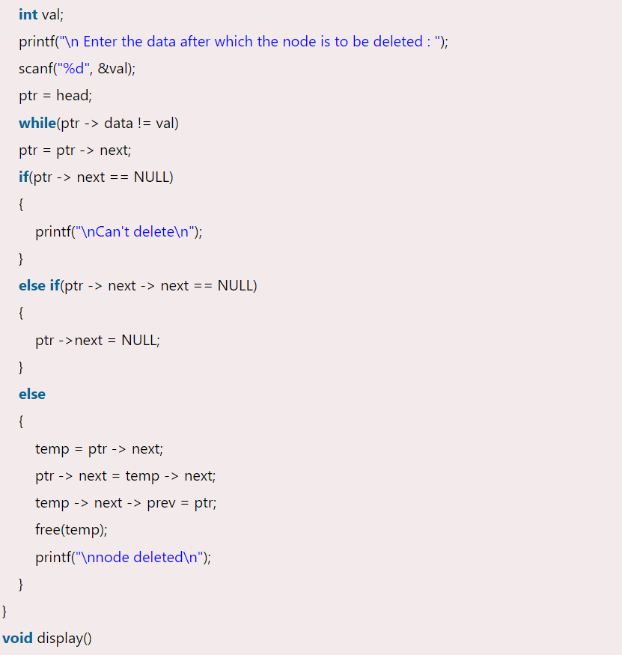
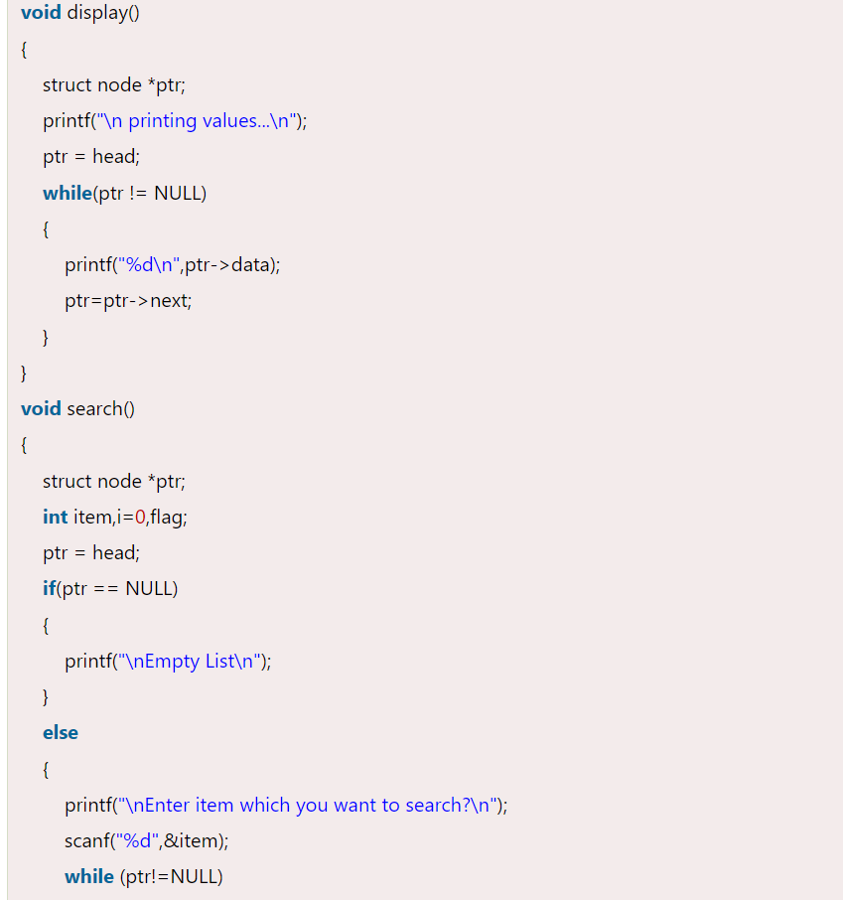
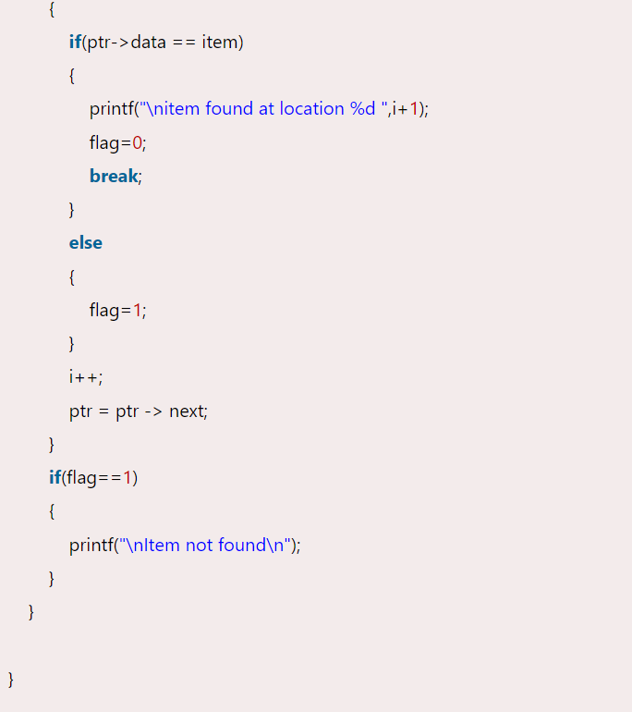


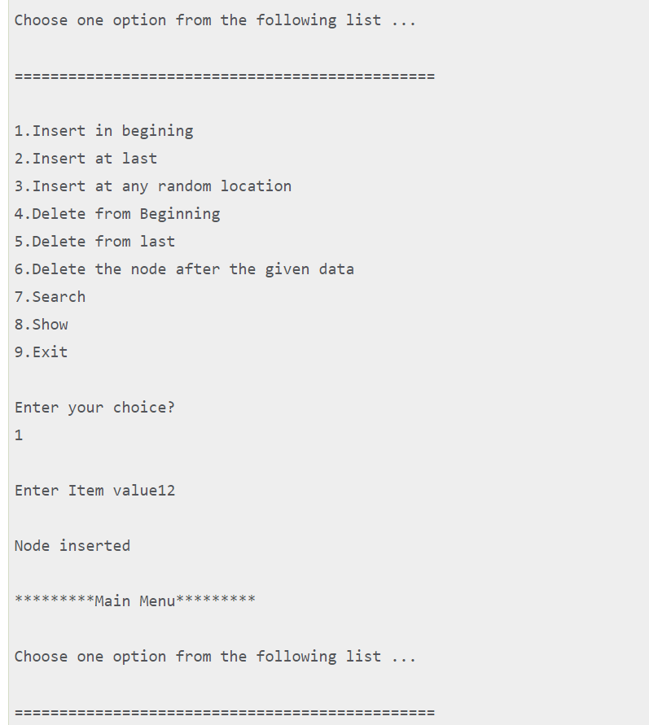
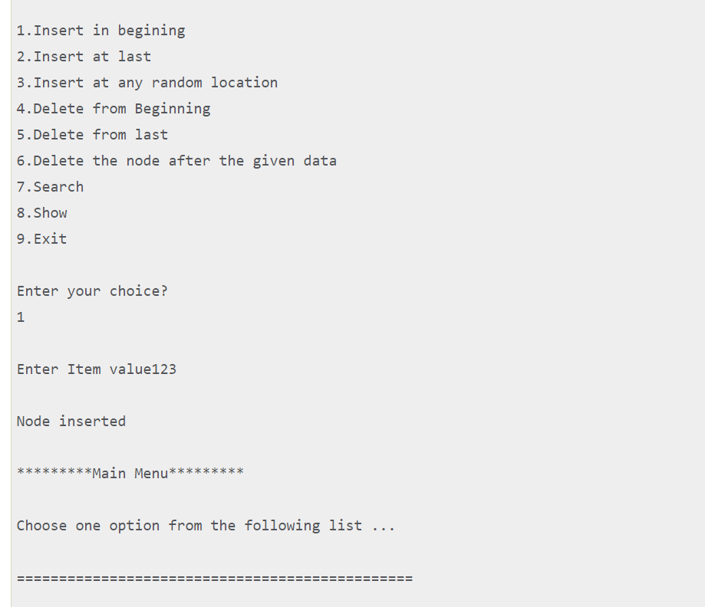
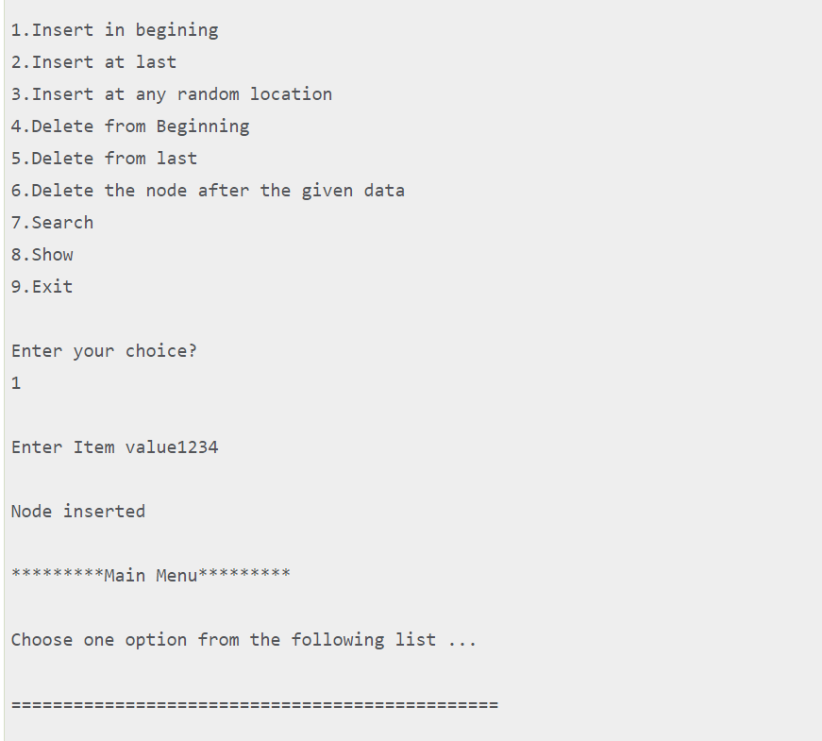
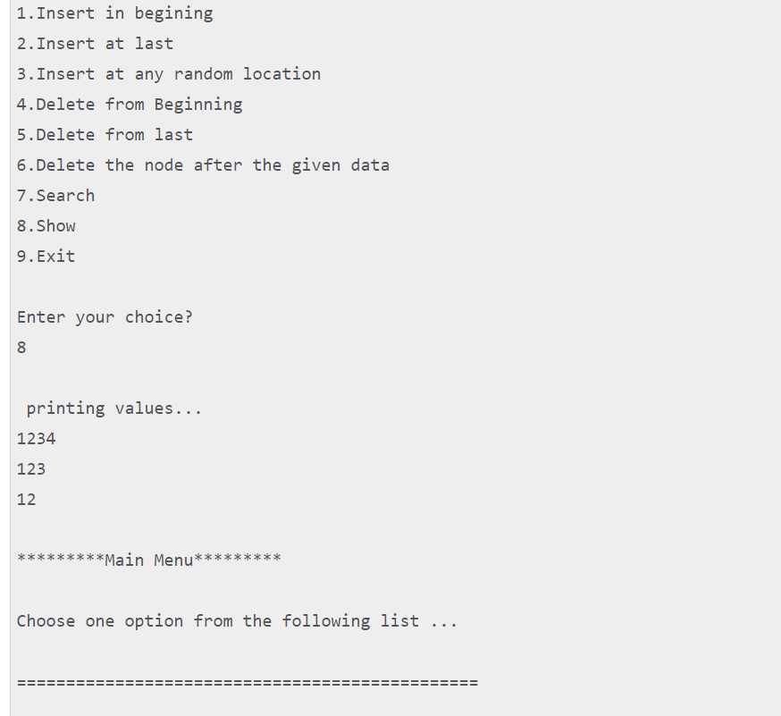
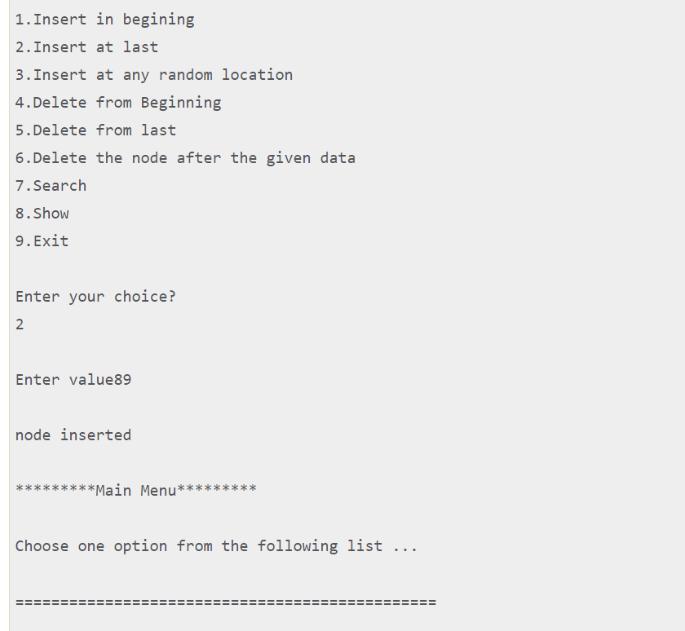
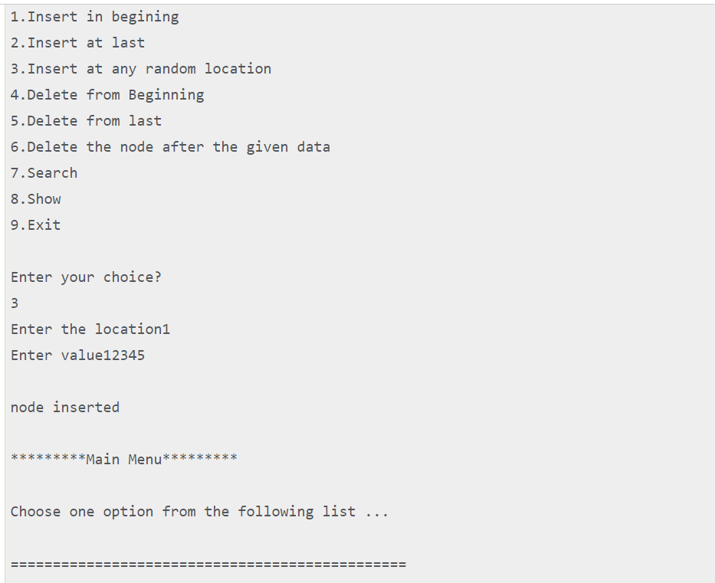
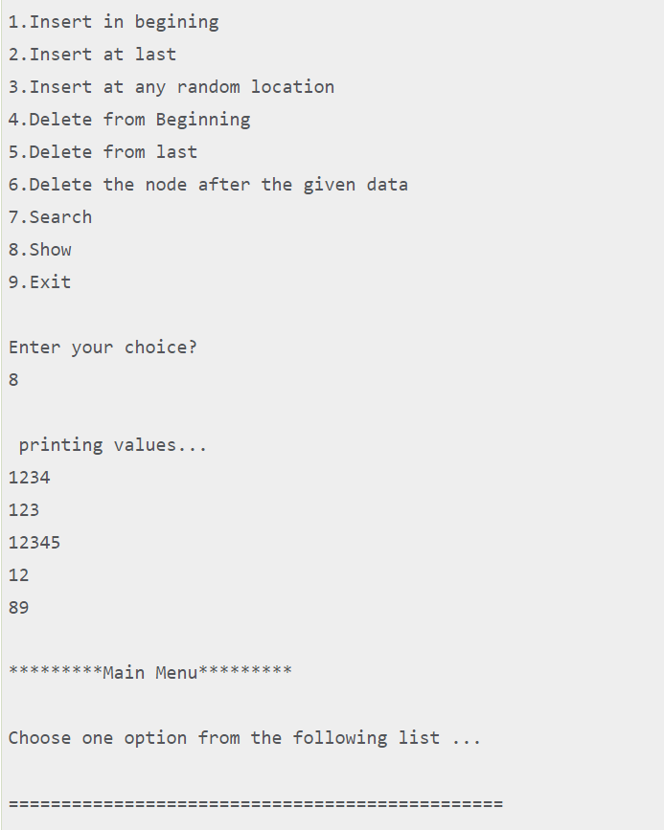
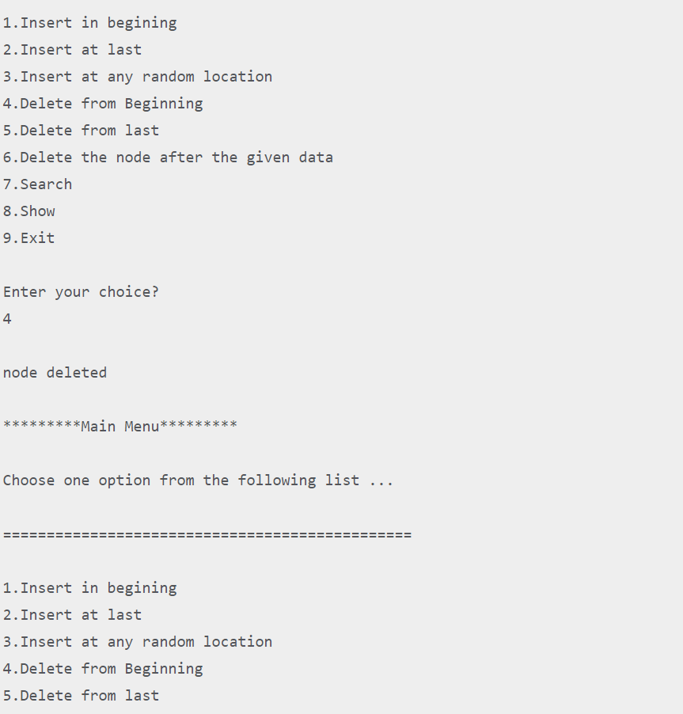
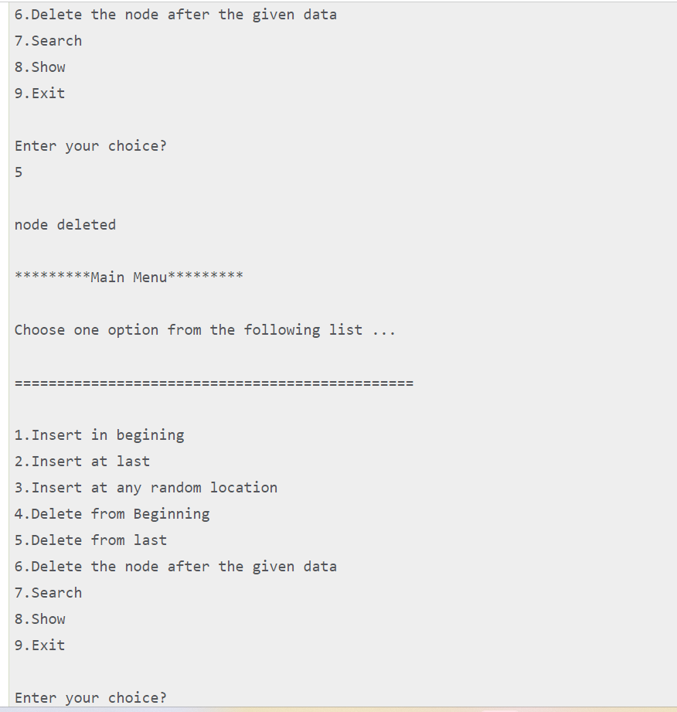

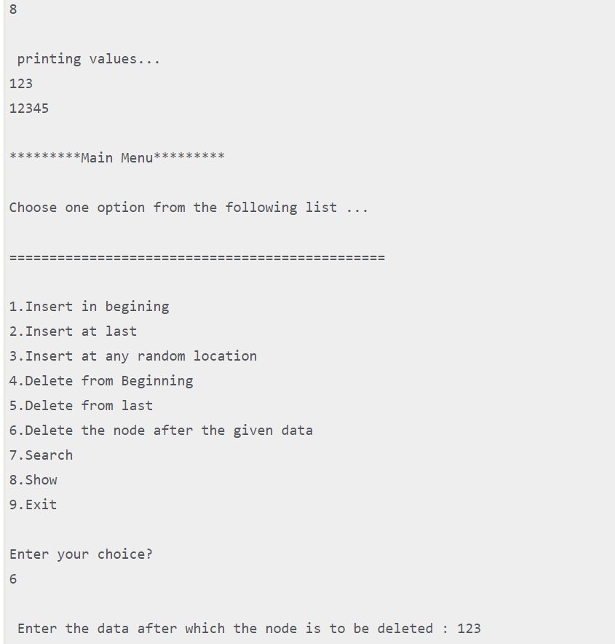

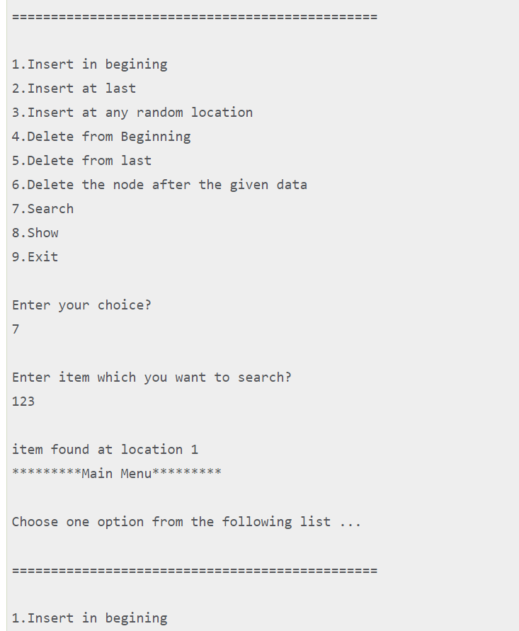
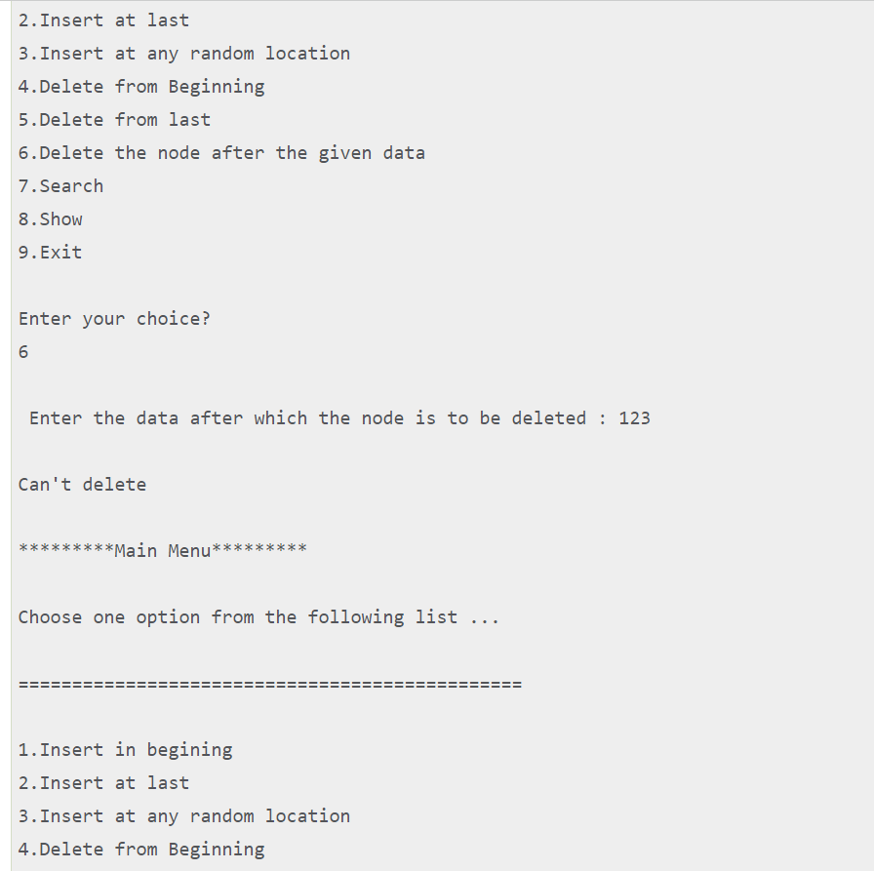
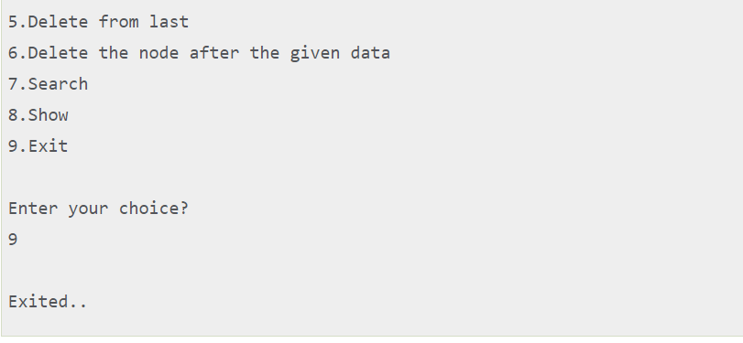

Binary Tree
A binary tree is a tree data structure in which each node can have at most two children, which are referred to as the left child and the right child.
The topmost node in a binary tree is called the root, and the bottom-most nodes are called leaves. A binary tree can be visualized as a hierarchical structure with the root at the top and the leaves at the bottom.
Binary trees have many applications in computer science, including data storage and retrieval, expression evaluation, network routing, and game AI. They can also be used to implement various algorithms such as searching, sorting, and graph algorithms.

Representation of Binary Tree:
Each node in the tree contains the following:
- Data
- Pointer to the left child
- Pointer to the right child
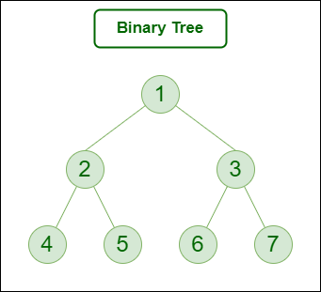
Binary Tree
In C, we can represent a tree node using structures. In other languages, we can use classes as part of their OOP feature. Below is an example of a tree node with integer data.
// Structure of each node of the tree

struct node {
int data;
struct node* left;
struct node* right;
};

Basic Operations On Binary Tree:
- Inserting an element.
- Removing an element.
- Searching for an element.
- Deletion for an element.
- Traversing an element. There are four (mainly three) types of traversals in a binary tree which will be discussed ahead.

Auxiliary Operations On Binary Tree:
- Finding the height of the tree
- Find the level of the tree
- Finding the size of the entire tree.

Applications of Binary Tree:
- In compilers, Expression Trees are used which is an application of binary trees.
- Huffman coding trees are used in data compression algorithms.
- Priority Queue is another application of binary tree that is used for searching maximum or minimum in O(1) time complexity.
- Represent hierarchical data.
- Used in editing software like Microsoft Excel and spreadsheets.
- Useful for indexing segmented at the database is useful in storing cache in the system,
- Syntax trees are used for most famous compilers for programming like GCC, and AOCL to perform arithmetic operations.
- For implementing priority queues.
- Used to find elements in less time (binary search tree)
- Used to enable fast memory allocation in computers.
- Used to perform encoding and decoding operations.
- Binary trees can be used to organize and retrieve information from large datasets, such as in inverted index and k-d trees.
- Binary trees can be used to represent the decision-making process of computer-controlled characters in games, such as in decision trees.
- Binary trees can be used to implement searching algorithms, such as in binary search trees which can be used to quickly find an element in a sorted list.
- Binary trees can be used to implement sorting algorithms, such as in heap sort which uses a binary heap to sort elements efficiently.

Binary Tree Traversals:
Tree Traversal algorithms can be classified broadly into two categories:
- Depth-First Search (DFS) Algorithms
- Breadth-First Search (BFS) Algorithms

Tree Traversal using Depth-First Search (DFS) algorithm can be further classified into three categories:
- Preorder Traversal (current-left-right): Visit the current node before visiting any nodes inside the left or right subtrees. Here, the traversal is root – left child – right child. It means that the root node is traversed first then its left child and finally the right child.
- Inorder Traversal (left-current-right): Visit the current node after visiting all nodes inside the left subtree but before visiting any node within the right subtree. Here, the traversal is left child – root – right child. It means that the left child is traversed first then its root node and finally the right child.
- Postorder Traversal (left-right-current): Visit the current node after visiting all the nodes of the left and right subtrees. Here, the traversal is left child – right child – root. It means that the left child has traversed first then the right child and finally its root node.

Tree Traversal using Breadth-First Search (BFS) algorithm can be further classified into one category:
- Level Order Traversal: Visit nodes level-by-level and left-to-right fashion at the same level. Here, the traversal is level-wise. It means that the most left child has traversed first and then the other children of the same level from left to right have traversed.
Let us traverse the following tree with all four traversal methods:
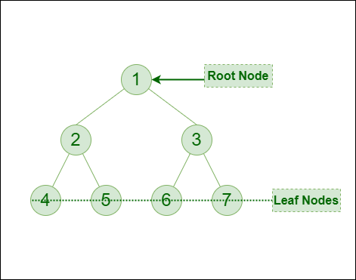
Binary Tree
Pre-order Traversal of the above tree: 1-2-4-5-3-6-7
In-order Traversal of the above tree: 4-2-5-1-6-3-7
Post-order Traversal of the above tree: 4-5-2-6-7-3-1
Level-order Traversal of the above tree: 1-2-3-4-5-6-7

Implementation of Binary Tree:
Let us create a simple tree with 4 nodes. The created tree would be as follows.
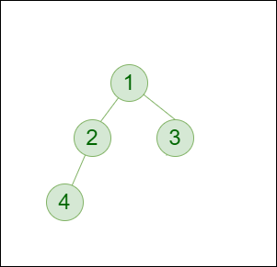
Below is the Implementation of the binary tree:
#include <stdio.h>
#include <stdlib.h>

struct node {
int data;
struct node* left;
struct node* right;
};

// newNode() allocates a new node
// with the given data and NULL left
// and right pointers.
struct node* newNode(int data)
{
// Allocate memory for new node
struct node* node
= (struct node*)malloc(sizeof(struct node));

// Assign data to this node
node->data = data;

// Initialize left and
// right children as NULL
node->left = NULL;
node->right = NULL;
return (node);
}

int main()
{
// Create root
struct node* root = newNode(1);

/* following is the tree after above statement
1
/ \
NULL NULL
*/
root->left = newNode(2);
root->right = newNode(3);

/* 2 and 3 become left and right children of 1
1
/ \
2 3
/ \ / \
NULL NULL NULL NULL
*/
root->left->left = newNode(4);

/* 4 becomes left child of 2
1
/ \
2 3
/ \ / \
4 NULL NULL NULL
/ \
NULL NULL
*/
getchar();
return 0;
}

Properties of Binary Tree
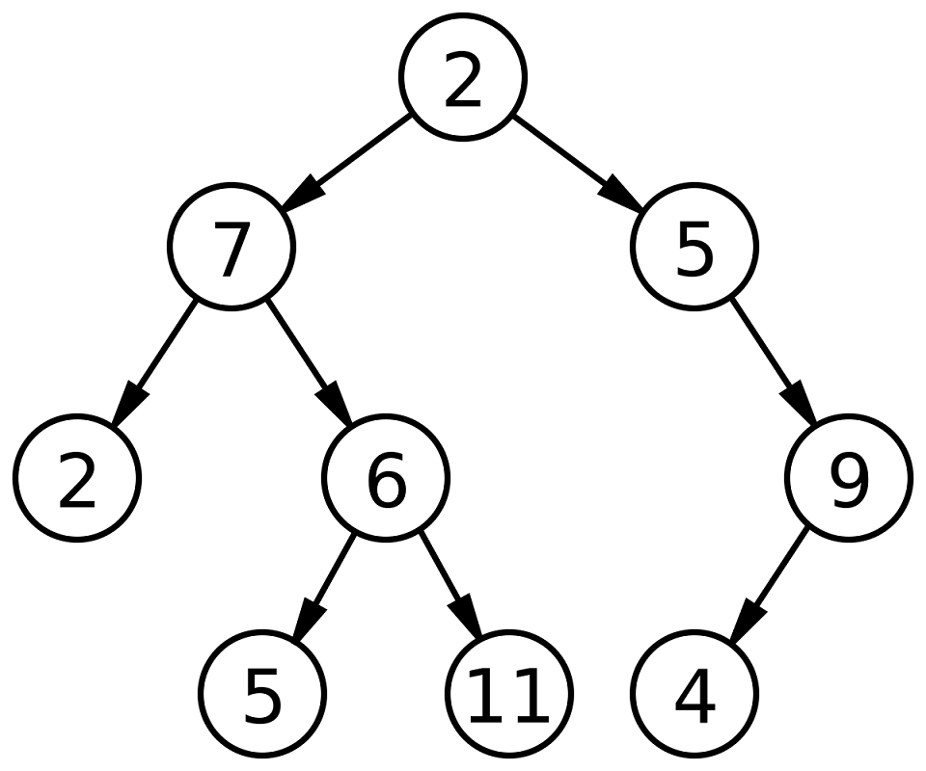

1. The maximum number of nodes at level ‘l’ of a binary tree is 2^{l}:
Note: Here level is the number of nodes on the path from the root to the node (including root and node). The level of the root is 0
This can be proved by induction:
For root, l = 0, number of nodes = 2⁰ = 1
Assume that the maximum number of nodes on level ‘l’ is 2^{l}
Since in a Binary tree every node has at most 2 children, the next level would have twice nodes, i.e. 2 * 2^{l}

2. The Maximum number of nodes in a binary tree of height ‘h’ is 2^{h} – 1:
Note: Here the height of a tree is the maximum number of nodes on the root-to-leaf path. The height of a tree with a single node is considered as 1
This result can be derived from point 2 above. A tree has maximum nodes if all levels have maximum nodes. So the maximum number of nodes in a binary tree of height h is 1 + 2 + 4 + .. + 2^{h-1}. This is a simple geometric series with h terms and the sum of this series is 2^{h}– 1.
In some books, the height of the root is considered as 0. In this convention, the above formula becomes 2^{h+1} – 1

3. In a Binary Tree with N nodes, the minimum possible height or the minimum number of levels is Log₂(N+1):
Each level should have at least one element, so the height cannot be more than N. A binary tree of height ‘h’ can have a maximum of 2^{h} – 1 nodes (previous property). So the number of nodes will be less than or equal to this maximum value
N <= 2^{h} – 1
2^{h} >= N+1
log₂(2^{h}) >= log₂(N+1) (Taking log both sides)
hlog₂2 >= log₂(N+1) (h is an integer)
h >= | log₂(N+1) |
So the minimum height possible is | log₂(N+1) |

4. A Binary Tree with L leaves has at least | Log₂L |+ 1 levels:
A Binary tree has the maximum number of leaves (and a minimum number of levels) when all levels are fully filled. Let all leaves be at level l, then below is valid for the number of leaves L
L <= 2^{l-1} [From Point 1] [Note: Here, consider level of root node as 1]
l = | Log₂L | + 1
where l is the minimum number of levels

5. In a Binary tree where every node has 0 or 2 children, the number of leaf nodes is always one more than nodes with two children:
L = T + 1
Where L = Number of leaf nodes
T = Number of internal nodes with two children
Proof:
No. of leaf nodes (L) i.e. total elements present at the bottom of tree = 2^{h-1} (h is height of tree)
No. of internal nodes = {total no. of nodes} – {leaf nodes} = { 2^{h} – 1 } – {2^{h-1}} = 2^{h-1} (2-1) – 1 = 2^{h-1} – 1
So , L = 2^{h-1}
T = 2^{h-1} – 1
Therefore L = T + 1
Hence proved

6. In a non-empty binary tree, if n is the total number of nodes and e is the total number of edges, then e = n-1:
Every node in a binary tree has exactly one parent with the exception of the root node. So if n is the total number of nodes then n-1 nodes have exactly one parent. There is only one edge between any child and its parent. So the total number of edges is n-1.

Some extra properties of binary tree are:
- Each node in a binary tree can have at most two child nodes: In a binary tree, each node can have either zero, one, or two child nodes. If a node has zero children, it is called a leaf node. If a node has one child, it is called a unary node. If a node has two children, it is called a binary node.
- The node at the top of the tree is called the root node: The root node is the first node in a binary tree and all other nodes are connected to it. All other nodes in the tree are either child nodes or descendant nodes of the root node.
- Nodes that do not have any child nodes are called leaf nodes: Leaf nodes are the endpoints of the tree and have no children. They represent the final result of the tree.
- The height of a binary tree is defined as the number of edges from the root node to the deepest leaf node: The height of a binary tree is the length of the longest path from the root node to any of the leaf nodes. The height of a binary tree is also known as its depth.
- In a full binary tree, every node except the leaves has exactly two children: In a full binary tree, all non-leaf nodes have exactly two children. This means that there are no unary nodes in a full binary tree.
- In a complete binary tree, every level of the tree is completely filled except for the last level, which can be partially filled: In a complete binary tree, all levels of the tree except the last level are completely filled. This means that there are no gaps in the tree and all nodes are connected to their parent nodes.
- In a balanced binary tree, the height of the left and right subtrees of every node differ by at most 1: In a balanced binary tree, the height of the left and right subtrees of every node is similar. This ensures that the tree is balanced and that the height of the tree is minimized.
- The in-order, pre-order, and post-order traversal of a binary tree are three common ways to traverse the tree: In-order, pre-order, and post-order are three different ways to traverse a binary tree. In-order traversal visits the left subtree, the node itself, and then the right subtree. Pre-order traversal visits the node itself, the left subtree, and then the right subtree. Post-order traversal visits the left subtree, the right subtree, and then the node itself.

Binary Tree (Array implementation)
Given an array that represents a tree in such a way that array indexes are values in tree nodes and array values give the parent node of that particular index (or node). The value of the root node index would always be -1 as there is no parent for root. Construct the standard linked representation of given Binary Tree from this given representation.

Ways to represent:
Trees can be represented in two ways as listed below:
- Dynamic Node Representation (Linked Representation).
- Array Representation (Sequential Representation).
In order to represent a tree using an array, the numbering of nodes can start either from 0–(n-1) or 1– n, consider the below illustration as follows:
Illustration:
A(0)
/ \
B(1) C(2)
/ \ \
D(3) E(4) F(6)
OR,
A(1)
/ \
B(2) C(3)
/ \ \
D(4) E(5) F(7)

Procedure:
Note: father, left_son and right_son are the values of indices of the array.
Case 1: (0—n-1)
if (say)father=p;
then left_son=(2*p)+1;
and right_son=(2*p)+2;
Case 2: 1—n
if (say)father=p;
then left_son=(2*p);
and right_son=(2*p)+1;

Implementation:

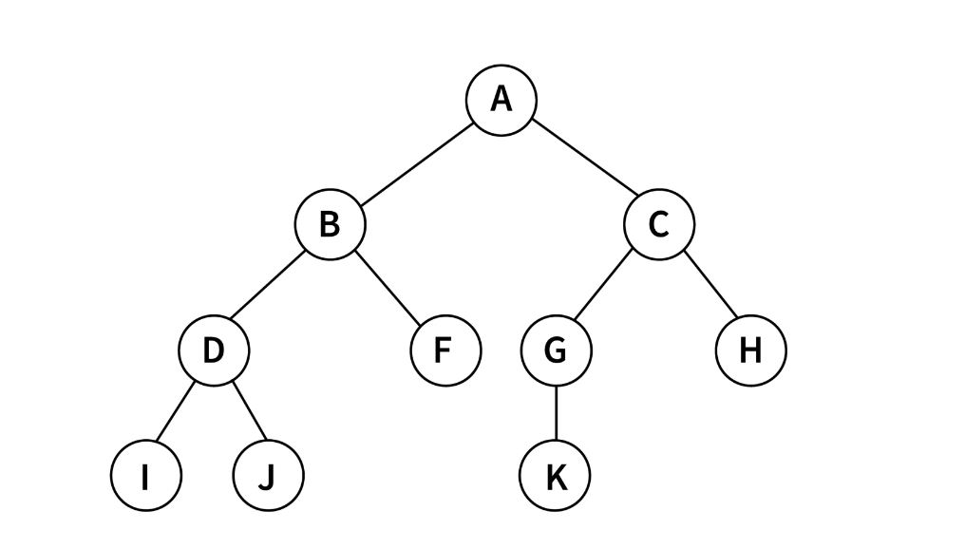

Array Representation :
The binary tree can be represented using an array of size 2n+1 if the depth of the binary tree is n. If the parent element is at the index p, Then the left child will be stored in the index (2p)+1, and the right child will be stored in the index (2p)+2.
The array representation of the above binary tree is :
As in the above binary tree, A was the root node, so that it will be stored in the 0th index. The left child of A will be stored in the 2(0)+1 equal to the 1st location. So, B is stored in index 1. And similarly, the right child of A will be stored in the 2(0)+2 index. For every node, the left and right child will be stored accordingly.
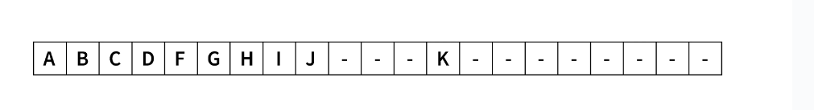

Linked List Representation :
For the linked list representation, we will use the doubly linked list, which has two pointers so that we can point to the left and right children of a binary tree node. NULL is given to the pointer as the address when no child is connected.

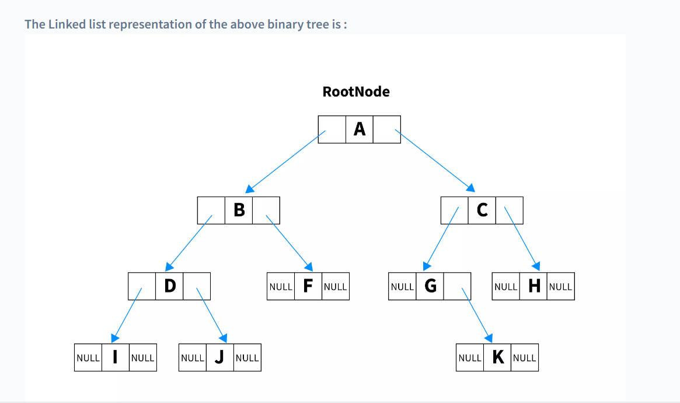

Need for Binary Trees
- Searching becomes easy and faster with the help of a binary search tree, even for huge data sets.
- Trees do not have a limit on the nodes. So, according to the user's need, a tree of any size can be created and further increased, unlike an array.
- It can store hierarchical data in the database.
- A binary tree can also be used for classification and decision-making.

Types of Binary Trees in C

Full Binary Tree
In a full binary tree, every node has either 0 or two children. It is also referred to as a strict binary tree.
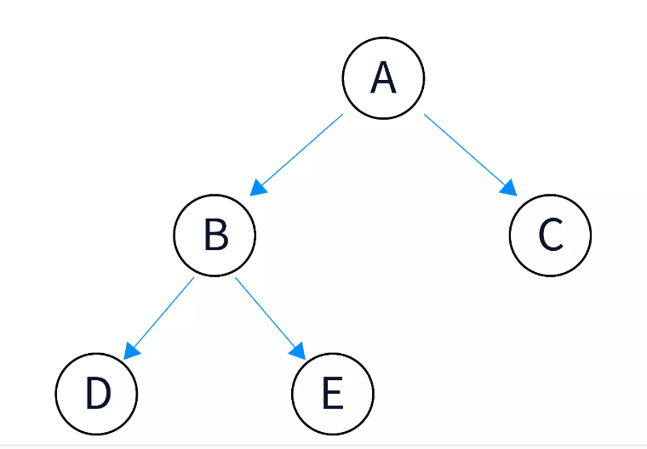

Perfect Binary Tree
As the name suggests, a perfect binary tree is one in which all the nodes(internal nodes) have two children and all the leaf nodes are at the same level.
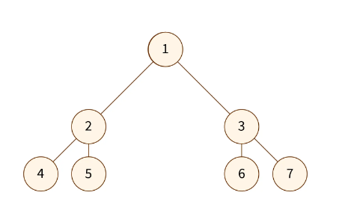

Complete Binary Tree
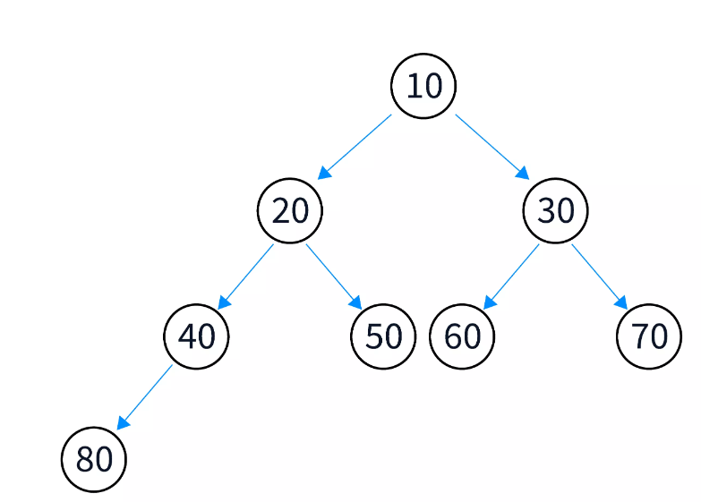

Balanced Binary Tree
It is a binary tree in which, for every node, the height of the left subtree and the height of the right subtree defer by zero or, at most, one.
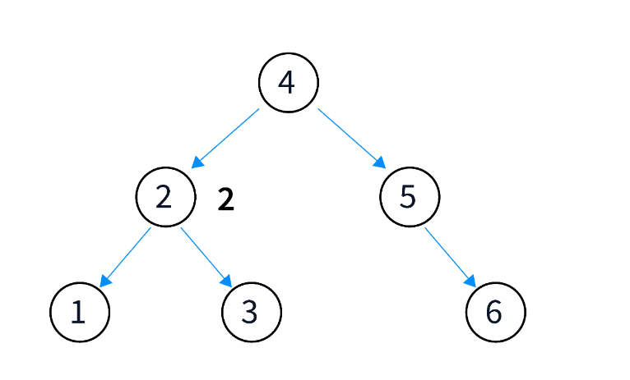

In a complete binary tree, all the levels except the last level(that contains the leaf nodes) should be full. In this type of binary tree, the node should be inserted to the left first, i.e., left-leaning (it is not mandatory to have a right sibling for the node).
Node Representation of Binary Trees:

In C programming, you can represent a binary tree using structures for nodes. Each node structure would contain the data, a pointer to the left child, and a pointer to the right child. Here's an example:
#include <stdio.h>
#include <stdlib.h>

// Definition of a TreeNode
struct TreeNode {
int data;
struct TreeNode* left;
struct TreeNode* right;
};

// Function to create a new node with a given data value
struct TreeNode* createNode(int data) {
struct TreeNode* newNode = (struct TreeNode*)malloc(sizeof(struct TreeNode));
newNode->data = data;
newNode->left = NULL;
newNode->right = NULL;
return newNode;
}

int main() {
// Creating nodes
struct TreeNode* root = createNode(1);
struct TreeNode* node2 = createNode(2);
struct TreeNode* node3 = createNode(3);

// Connecting nodes to form a binary tree
root->left = node2;
root->right = node3;

// You can continue adding nodes and building the tree based on your requirements

// Example: Adding nodes to the left and right of node2
node2->left = createNode(4);
node2->right = createNode(5);

// Example: Adding nodes to the left and right of node3
node3->left = createNode(6);
node3->right = createNode(7);

// Performing any additional operations on the binary tree

// Don't forget to free the allocated memory when you're done
free(root);
free(node2);
free(node3);

return 0;
}

In this example, the TreeNode structure defines the structure of each node in the binary tree. The createNode function is used to create a new node with a given data value.
You can create nodes and build the binary tree by linking them using the left and right pointers. Make sure to free the allocated memory when you are done using the free function to prevent memory leaks.

Internal and External Nodes:

In a binary tree, nodes can be categorized as internal nodes and external nodes (also known as leaf nodes). Internal nodes are those that have at least one child, while external nodes are nodes that do not have any children (also known as leaf nodes). Here's an example in C programming to demonstrate internal and external nodes in a binary tree:
#include <stdio.h>
#include <stdlib.h>

// Definition of a TreeNode
struct TreeNode {
int data;
struct TreeNode* left;
struct TreeNode* right;
};

// Function to create a new node with a given data value
struct TreeNode* createNode(int data) {
struct TreeNode* newNode = (struct TreeNode*)malloc(sizeof(struct TreeNode));
newNode->data = data;
newNode->left = NULL;
newNode->right = NULL;
return newNode;
}

// Function to check if a node is an internal node
int isInternalNode(struct TreeNode* node) {
return (node != NULL) && (node->left != NULL || node->right != NULL);
}

// Function to check if a node is an external node (leaf node)
int isExternalNode(struct TreeNode* node) {
return (node != NULL) && (node->left == NULL && node->right == NULL);
}

int main() {
// Creating nodes
struct TreeNode* root = createNode(1);
struct TreeNode* node2 = createNode(2);
struct TreeNode* node3 = createNode(3);
struct TreeNode* node4 = createNode(4);
struct TreeNode* node5 = createNode(5);
struct TreeNode* node6 = createNode(6);

// Connecting nodes to form a binary tree
root->left = node2;
root->right = node3;
node2->left = node4;
node2->right = node5;
node3->left = node6;

// Checking if nodes are internal or external
printf("Node 1 is %s\n", isInternalNode(root) ? "internal" : "external");
printf("Node 2 is %s\n", isInternalNode(node2) ? "internal" : "external");
printf("Node 4 is %s\n", isExternalNode(node4) ? "external" : "internal");

// Freeing allocated memory
free(root);
free(node2);
free(node3);
free(node4);
free(node5);
free(node6);

return 0;
}

In this example, the isInternalNode function checks if a given node is an internal node, and the isExternalNode function checks if a given node is an external node (leaf node). You can use these functions to determine the nature of the nodes in your binary tree.

